IHCC Website Management Manual

TABLE OF CONTENTS

1. Logging on as a Website Admin 2
2. Adding and Deleting Choir Members 3
3. Website File Upload Instructions 5
4. Updating Events on Front Page and Members Area 10
5. Sending SMS Text Messages 14
6. Setting up Polls 15
7. SIB Files Upload Procedure using FTP Client Software 20
8. Trouble Shooting 28
8.1 Creating a Backup and down loading it. 28
8.2 Checking Service Provider Status and Database status. 31
9. History 35

1. Logging on as a Website Admin
There are a total of 9 admin Login Usernames :-
ALTOREP
BASSREP
IHCC_Admin
MD
Membership
SECRETARY
Social
SOPRANOREP
TENORREP

In your browser type https://ipshospchoir.org.uk/admin. If you have forgotten your password click on “lost your password



Enter your Username or admin email address:-
altorep@ipshospchoir.org.uk, bassrep@ipshospchoir.org.uk, md@ipshospchoir.org.uk, membership.sec@ipshospchoir.org.uk,
phil@web-design.ltd.uk, secretary@ipshospchoir.org.uk, social.sec@ipshospchoir.org.uk, sopranorep@ipshospchoir.org.uk,
tenorep@ipshospchoir.org.uk. Then click on “Get New Password”. You will then receive an email with instructions.


2. Adding and Deleting Choir Members
First of all, you need to login to www.ipshospchoir.org.uk website with your membership username and password.
In the Members Only section go to Society documentation / IHCC admins only / then download the Choir members details document. Open file, enable editing, insert row, type in details. Create the sms address using the new members mobile number, (copy format of other entries). Then copy the line you’ve entered into a text file so you can use it to paste into the membership form and control panel for the email entries. Save the document then follow the upload instructions. Log off from the membership area of the website.

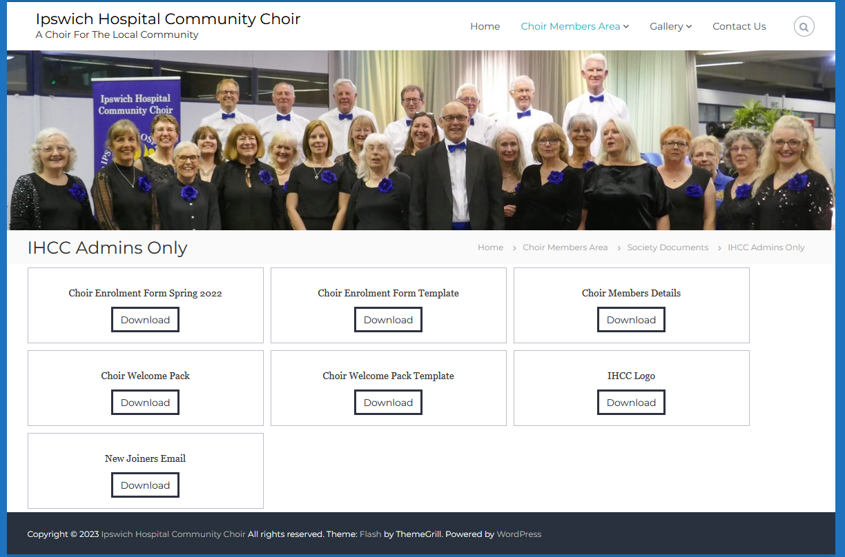
You now need to login to the website admin area: - www.ipshospchoir.org.uk/admin with your admin user and password. Click on WP Membership and follow the steps below: -

Members
Add new
User name=section-name of person (e.g., alto-Soo-norman)
Email -enter email address
Password – make up a password
Repeat password
Account status – active
Membership level – alto/soprano/tenor or bass
Access – todays date
First name – e.g., Soo
Last name – Norman
Gender
Mob number
Address – just put UK
Click add new member
Log out
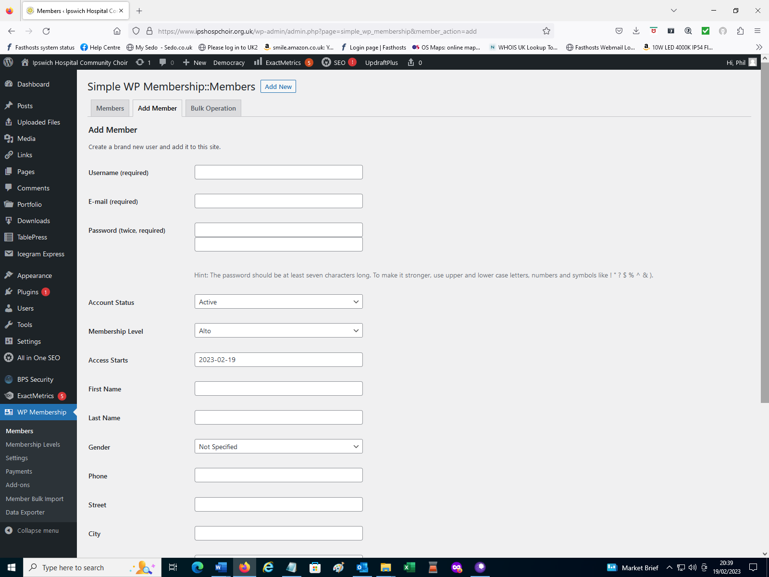
To add new members into the mailing list
Log into www.controlpanel.co.uk
Username :- IHCC committee
Password :- IHCCemail4u
Login
Manage your hosting packages
Click email
Click on link alto@ipshospchoir.org.uk (or sop/tenor/bass)
Mail forwarding
Configure
Enter email address by copying from the text entry copied from the Choir members details document.
Add
Save
To add new members into the SMS mailing list
Log into www.controlpanel.co.uk
IHCC committee
Login
Manage your hosting packages
Click email
Click on link alto.sms@ipshospchoir.org.uk (or sop/tenor/bass)
Mail forwarding
Configure
Enter the email address with the mobile number by copying from the text entry copied from the Choir members details document.
Add
Save
Then logout of the control panel.

3. Website File Upload Instructions

- Log in to the website using the following URL address: https://www.ipshospchoir.org.uk/admin and your own username and password.

- Hover over Downloads from the left menu bar and then single click Downloads from the list of options which appears.
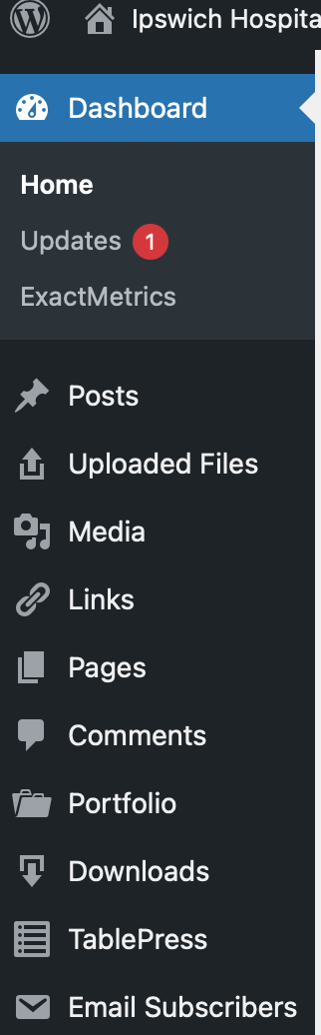

- From the next page, single click the Add New button.
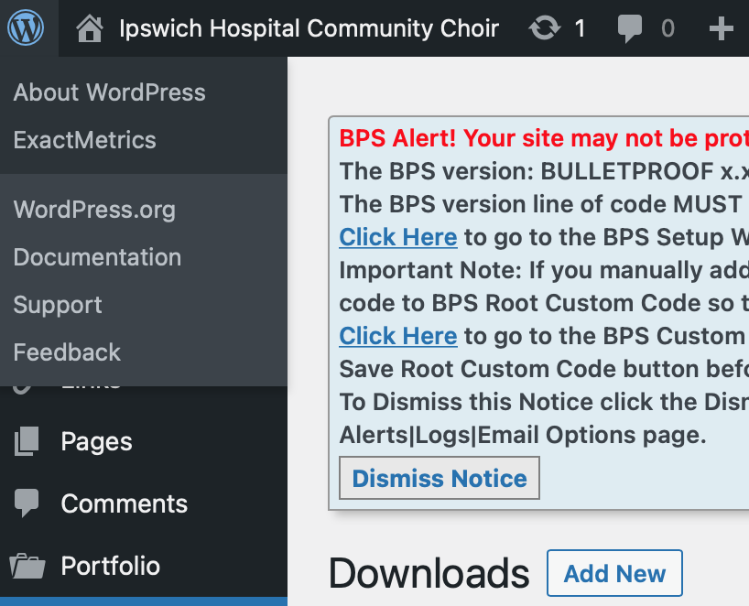

- Type in an appropriate title for your download in the Add Title box. For example, IHCC Minutes 251222 or Together In Electric Dreams (Tenor)

- Next, you are going to add the file which you are making available for download. Scroll down the page until you see the heading ‘Downloadable File (Visitors will download this item)’.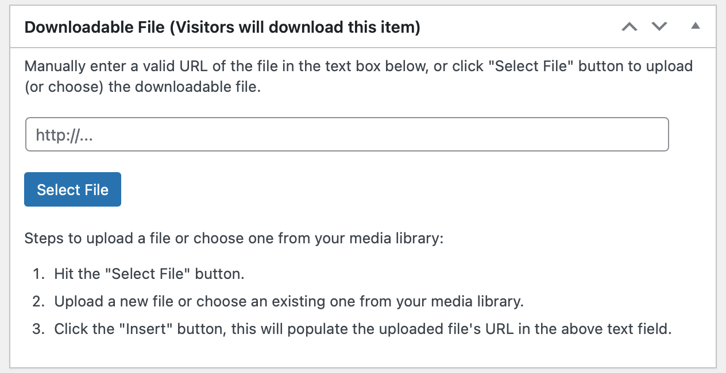
- Click the blue Select File button. This will take you to the Select File Page. Click the Upload files tab. 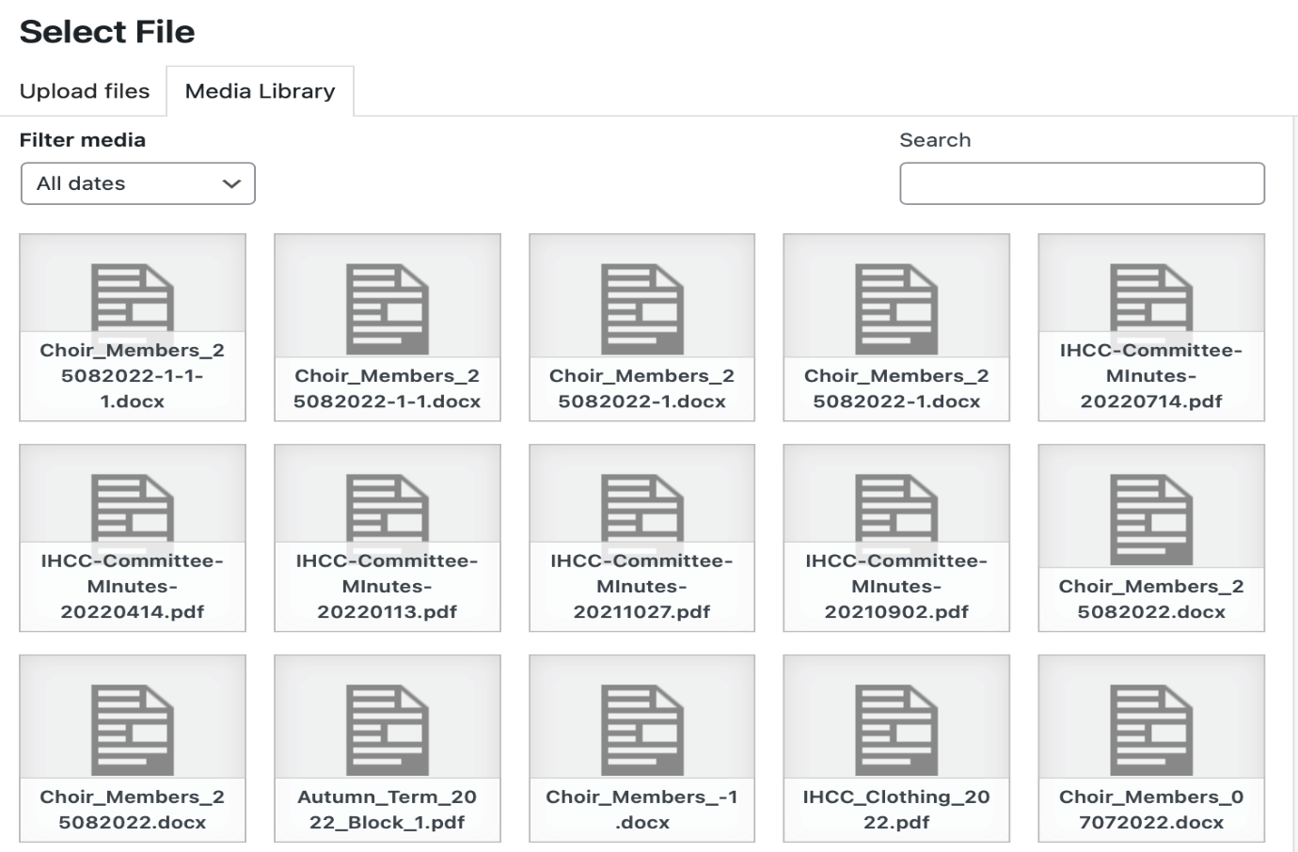

- The upload files tab takes you to the following page.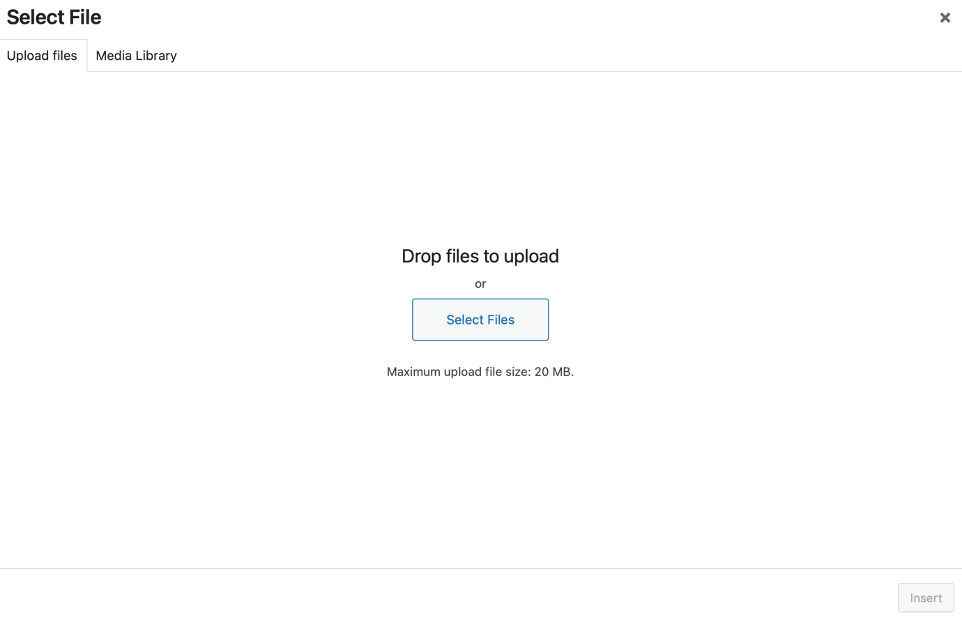Click the select files button, select the file for upload from your file directory and then click the blue upload button to upload the file. The file path will then appear in the downloadable file box.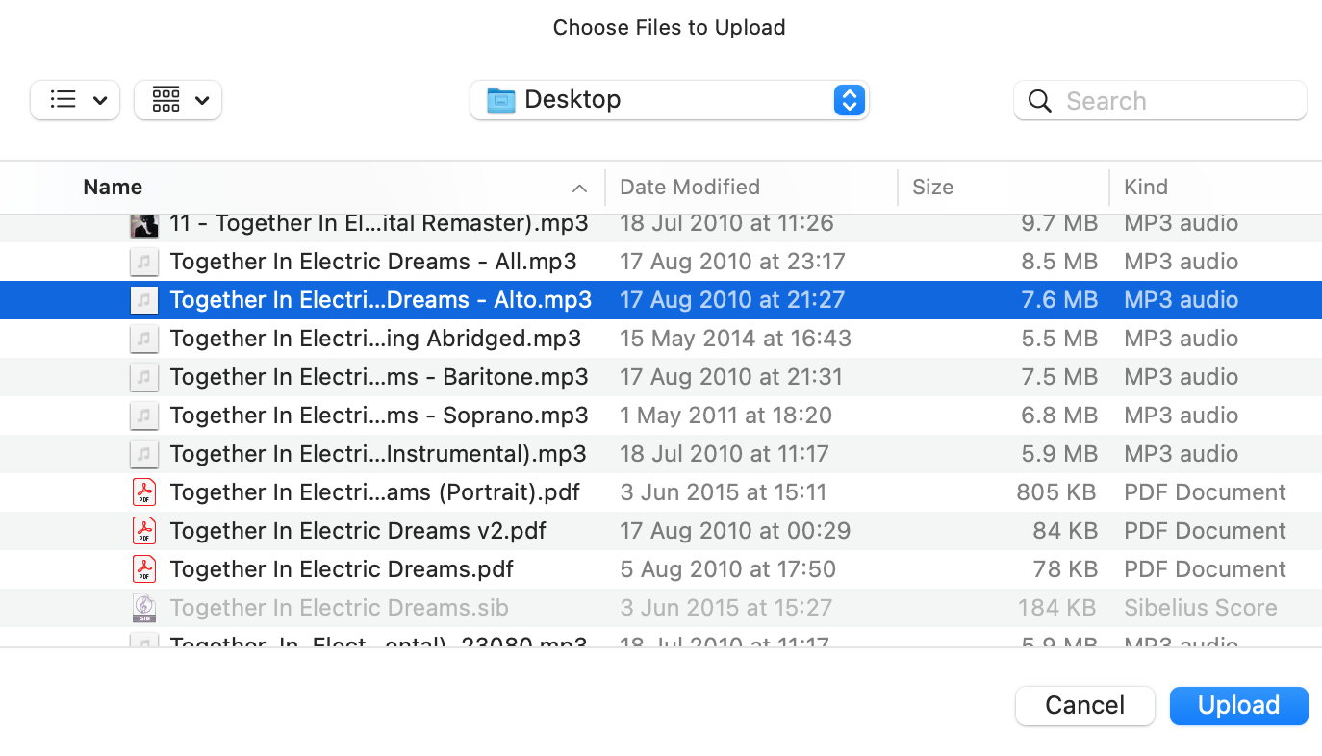
- You are now going to populate or click various boxes which categorise the type of file you have added and define where the file appears for users to download. Firstly, scroll down the page until you reach the ‘Other Details (Optional)’ section below. If you are unloading a music audio file, type into the ‘Version:’ field either Soprano, Alto, Tenor or Bass. If it’s a score, type Score. Be careful that you spell accurately because this is a free text cell. Also, make sure you click the ‘Show version number in fancy display’ tick box.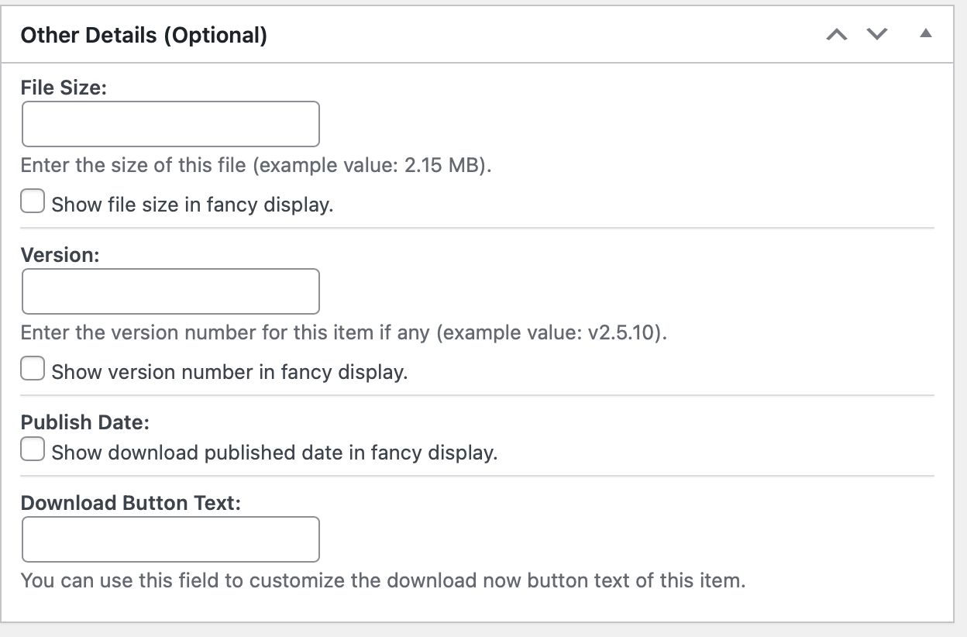

- Next, scroll further down the page until you reach the ‘Simple WP Membership Protection’ section. This section defines which choir membership group(s) can access the file you have uploaded. Tick the ‘Yes, Protect this content’ tick box. Then, tick the choir section to which your file relates. You must always tick the ‘Admin’ tick box and must also tick the correct section tick box. For files which are for all members of the choir, for example meeting minutes, you must tick all tick boxes. 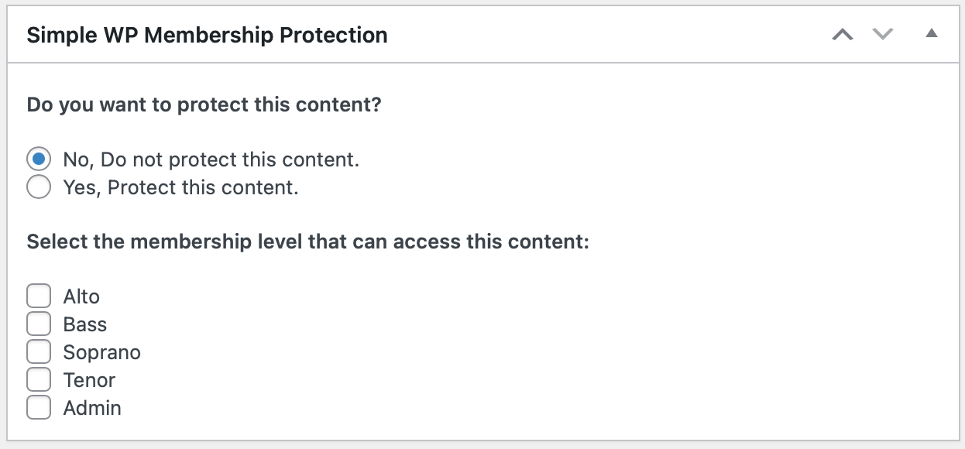

- Next, scroll up the page until you reach the ‘Download Categories’ section near the top on the right of the page. This section defines on which page of the website your file will be downloadable from. There are more categories than are visible initially so use the scroll bar on the right of the section to find more categories. Only tick one of the tick boxes, choosing the one which is relevant to the file you are adding. 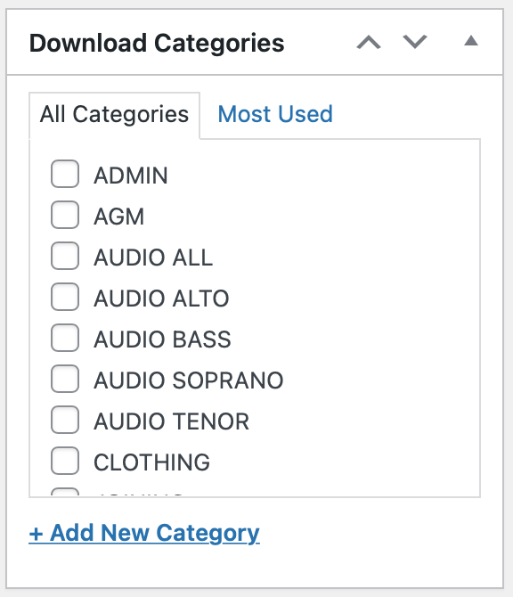

- Finally, scroll up to the ‘Publish’ section just above and click the blue Publish button. The download will then save and the new download file will be available for users to access.

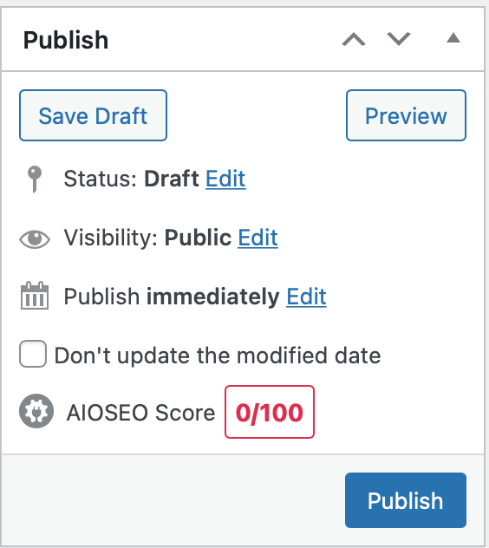

4. Updating Events on Front Page and Members Area
Updating Events

Login to https://ipshospchoir.org.uk/admin . From the Dashboard select “TablePress” “All Tables”.
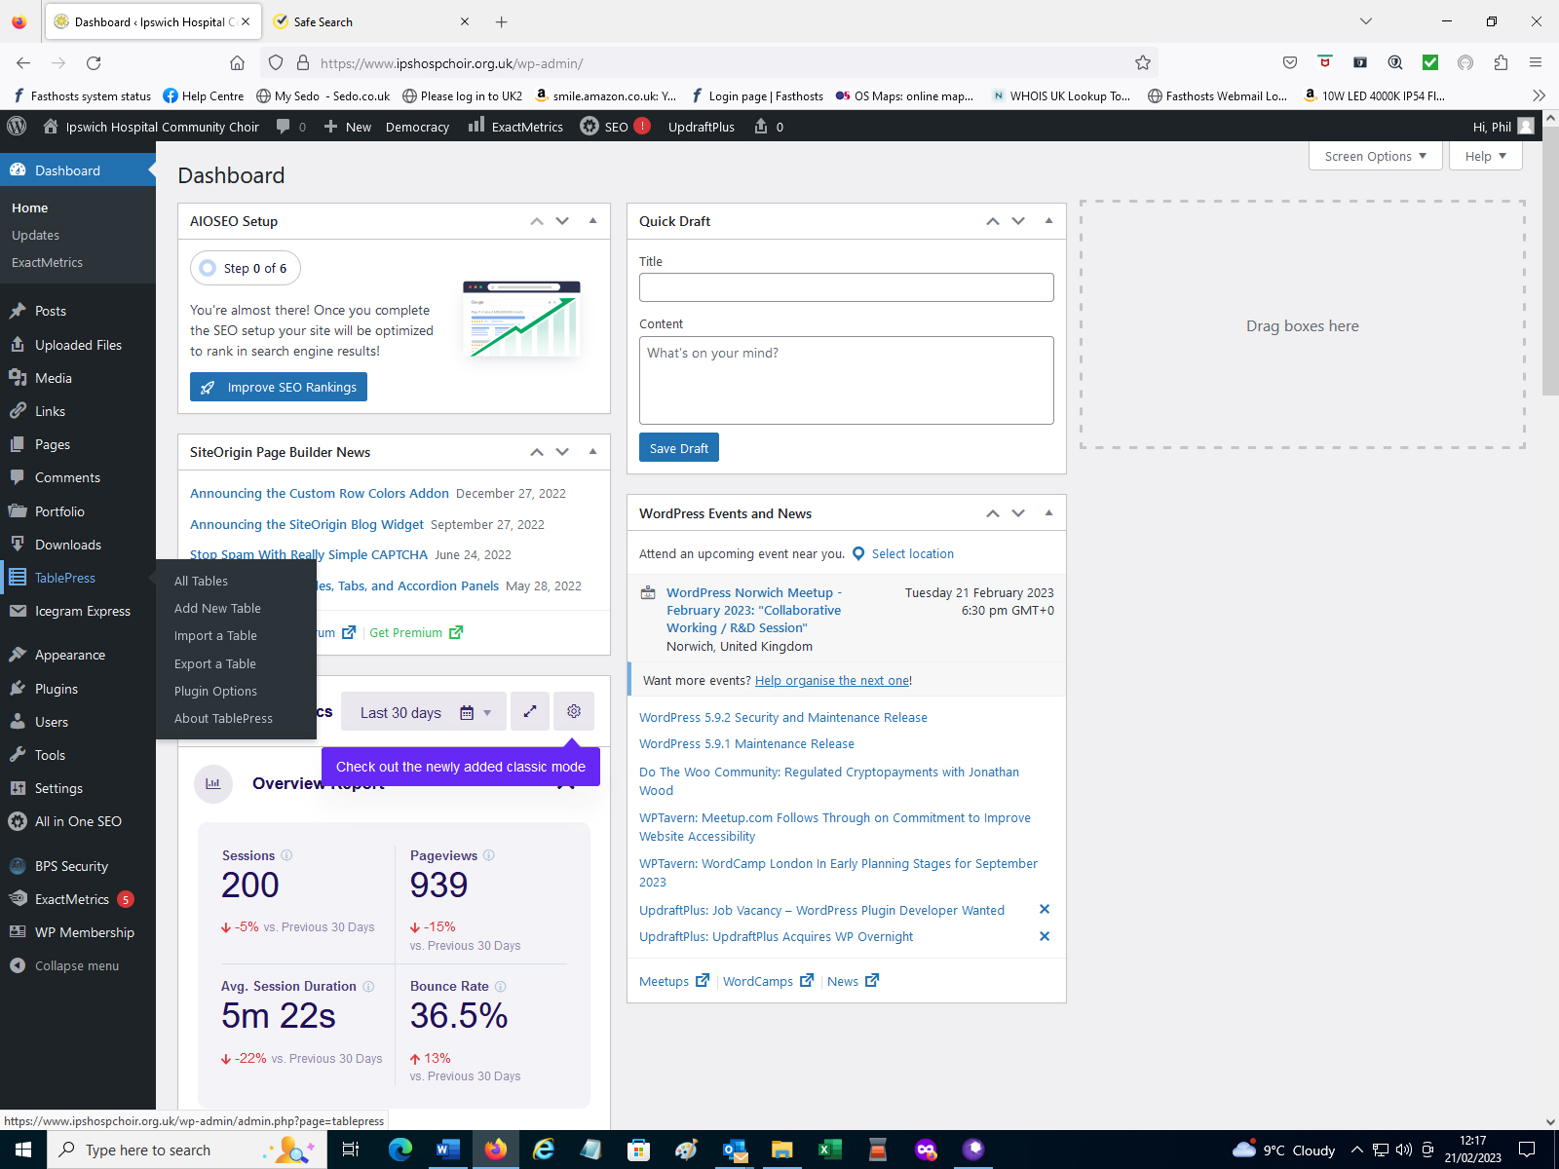
There are two Tables used on the Website. “Events” appears in the “Members Only” area. “Latest News” appears on the front page of the Website which can be viewed by the public. Click on the table you wish to update.
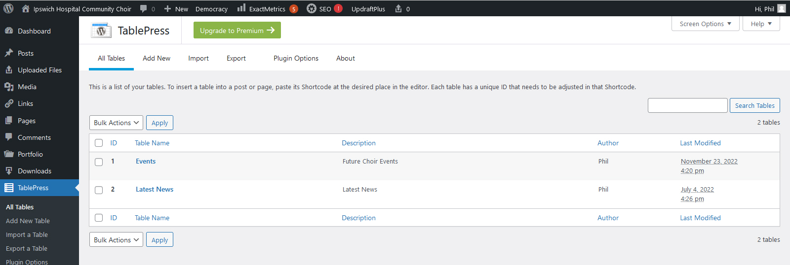

In the image below you will see “Events” that have now passed. Highlight a table entry you wish to delete.
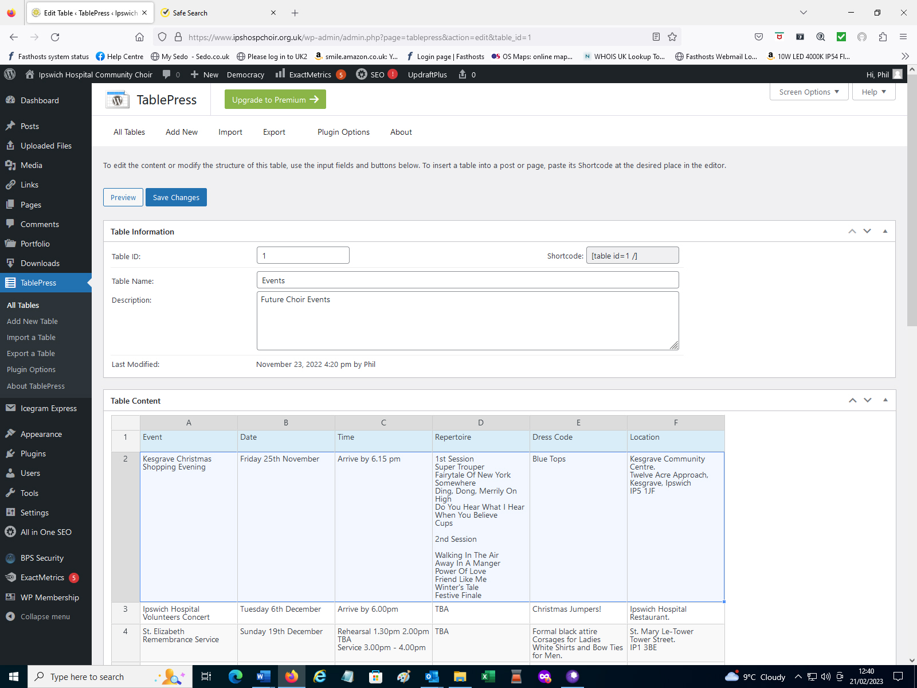
Further down the page you will see an area called “Table manipulation” On the line called “selected rows” click on “delete” to remove the highlighted row.
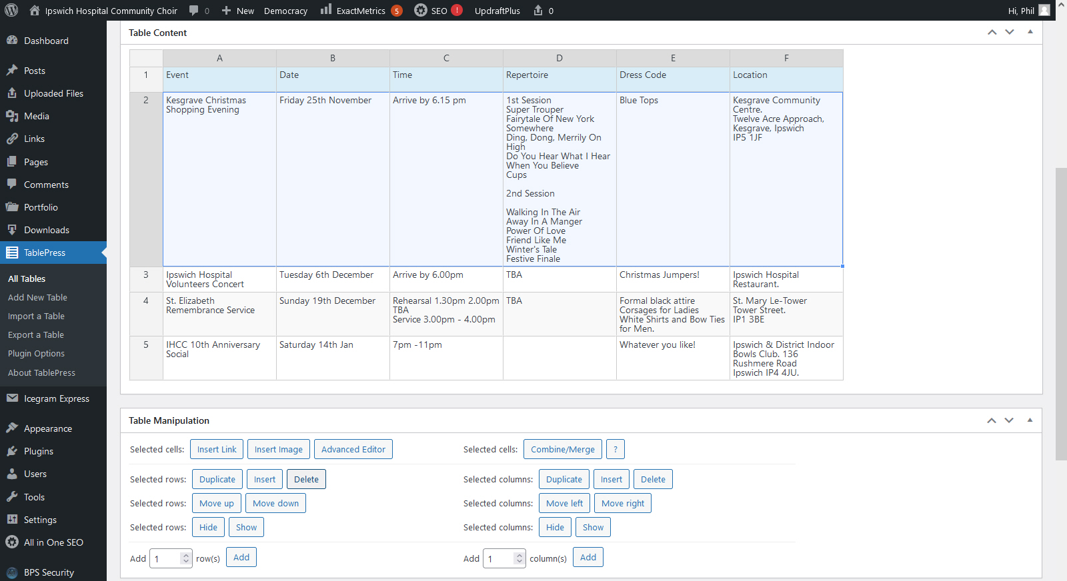

You will now see that the table entry has been removed. Repeat the procedure to remove further items that have passed. When you have completed deleting entries go back to the top of the page and click on “Save Changes”.
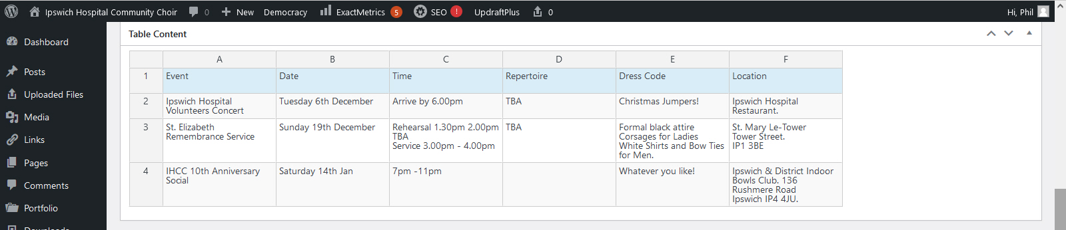
Adding events will now be demonstrated by clicking on “Latest News”.
Under “Table Content” line 1 just contains the title. To add a new “Event” under “Table Manipulation”, “Selected Rows” click on “Insert”
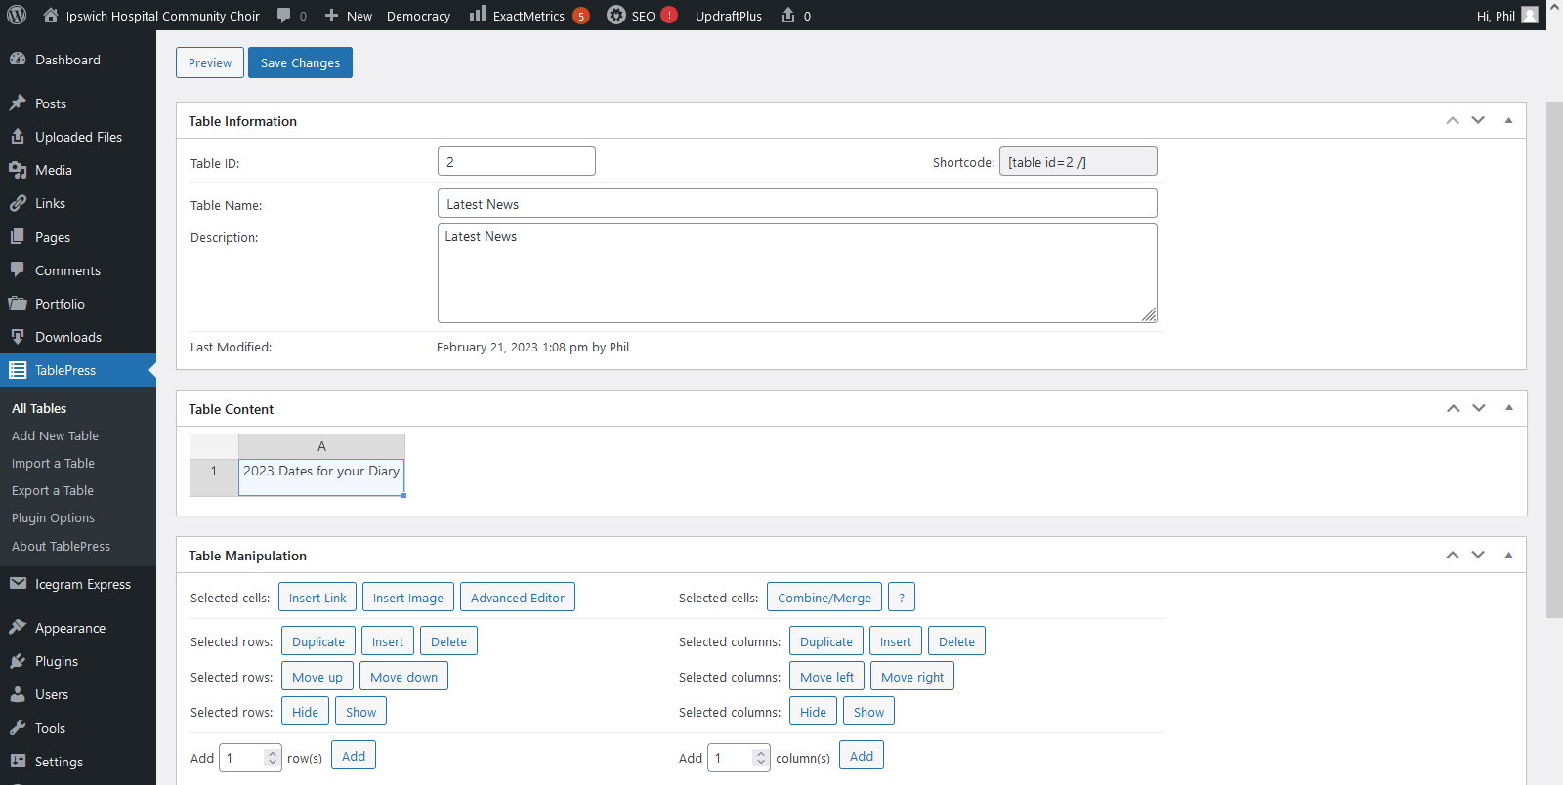

Under “Table Manipulation”, “Selected Cells” click on “Advanced Editor” and add your event details. Then click on “OK” and go back to the top of the page and click on “Save Changes”.
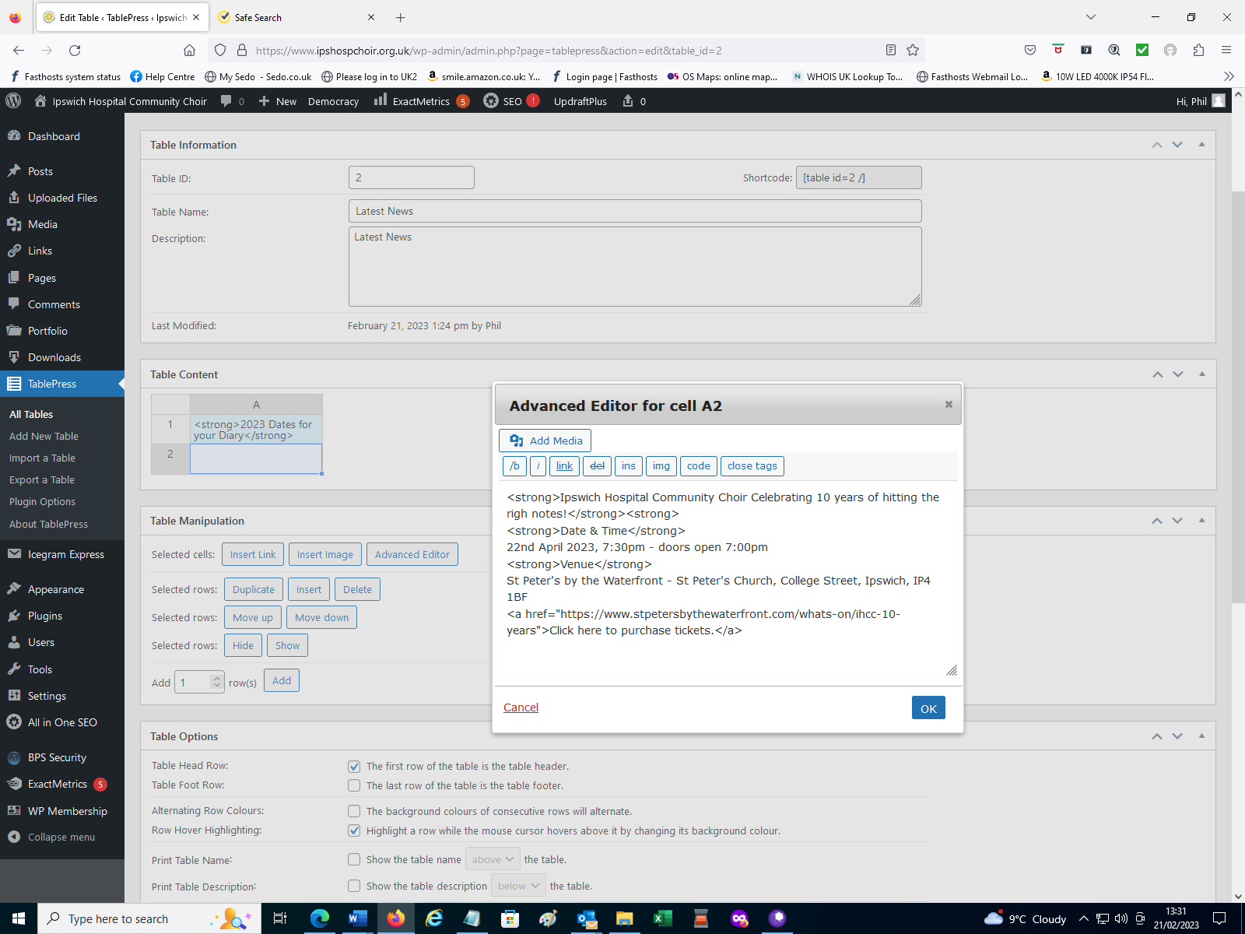

You can log off as Admin then check that the front page is displaying your added event: - https://ipshospchoir.org.uk

5. Sending SMS Text Messages
The following email addresses can be used to send text messages: -
alto.sms@ipshospchoir.org.uk
bass.sms@ipshospchoir.org.uk
committee.sms@ipshospchoir.org.uk
membership.sms@ipshospchoir.org.uk
soprano.sms@ipshospchoir.org.uk
tenor.sms@ipshospchoir.org.uk
All committee members have an email addressed with clicksend.com to use this service. You must use your registered email address for this service to work: -
alix6315@gmail.com
diane.ingledew@yahoo.com
fhamilton56@googlemail.com
ian.floodgate@gmail.com
nicoleman@sky.com
phil.riches@btinternet.com
soos.home@ntlworld.com
valtel.mcmahon@btinternet.com
Procedure: -
- Open a new email
- In the “To” field add the choir group you wish to send a text message to.
- “In the Subject Field” add your message i.e. “Please check your email”. Keep your message short as every character sent incurs a charge! E.g., sending the above to 40 people costs approximately £3.40.
- Do not type into the message field as this is not recognised by Clicksend.
- Send the email, you should receive a text message with a sender of “IHCC”.

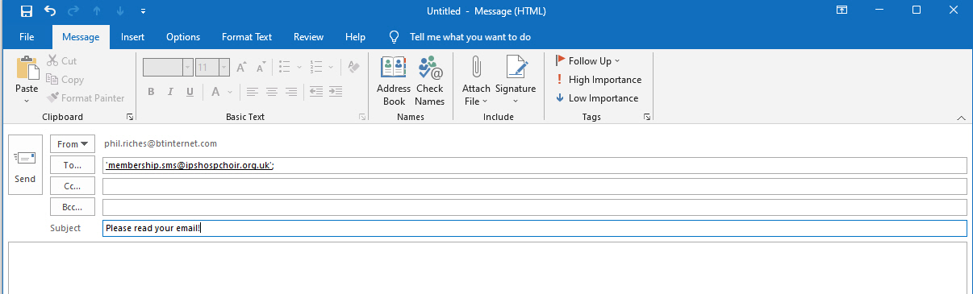

Setting up Polls
Login as a Website Admin:- https://www.ipshospchoir.org.uk/admin
At the top of the Dashboard Screen under Democracy click on “Add Poll”
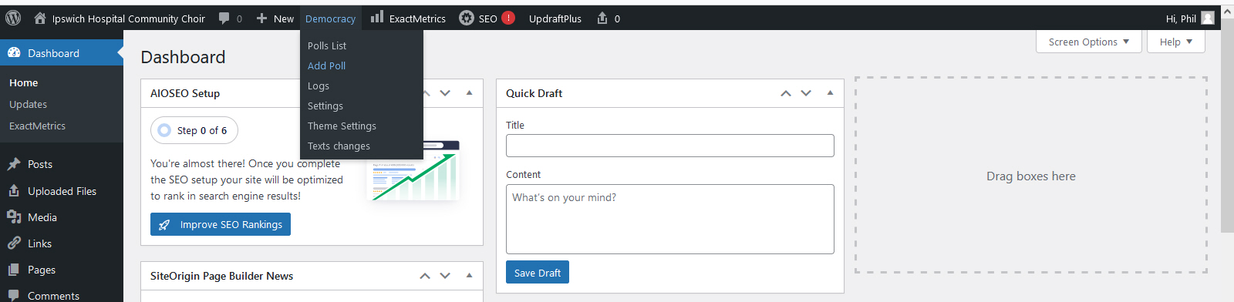
Add the following details: -
- Question
- Answers
- Date when Poll closes
Tick the following tick boxes: -
- Activate this poll
- Allow to change mind (revote)
- Allow to watch the results of the poll
Then click “Add Poll”
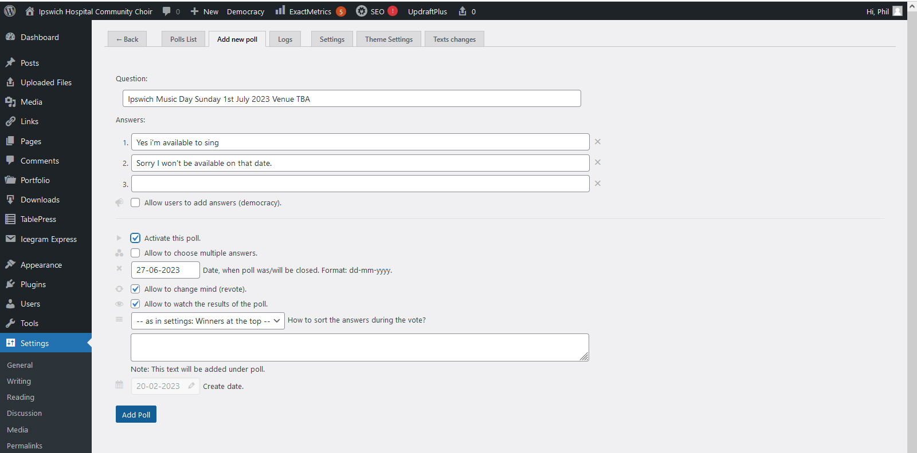

Copy the shortcode at the top of the page. In this example copy [democracy id=”12”].
If you wish you can add additional information about the concert in the “Note” text box at the bottom of the page. Click on “Save Changes”.
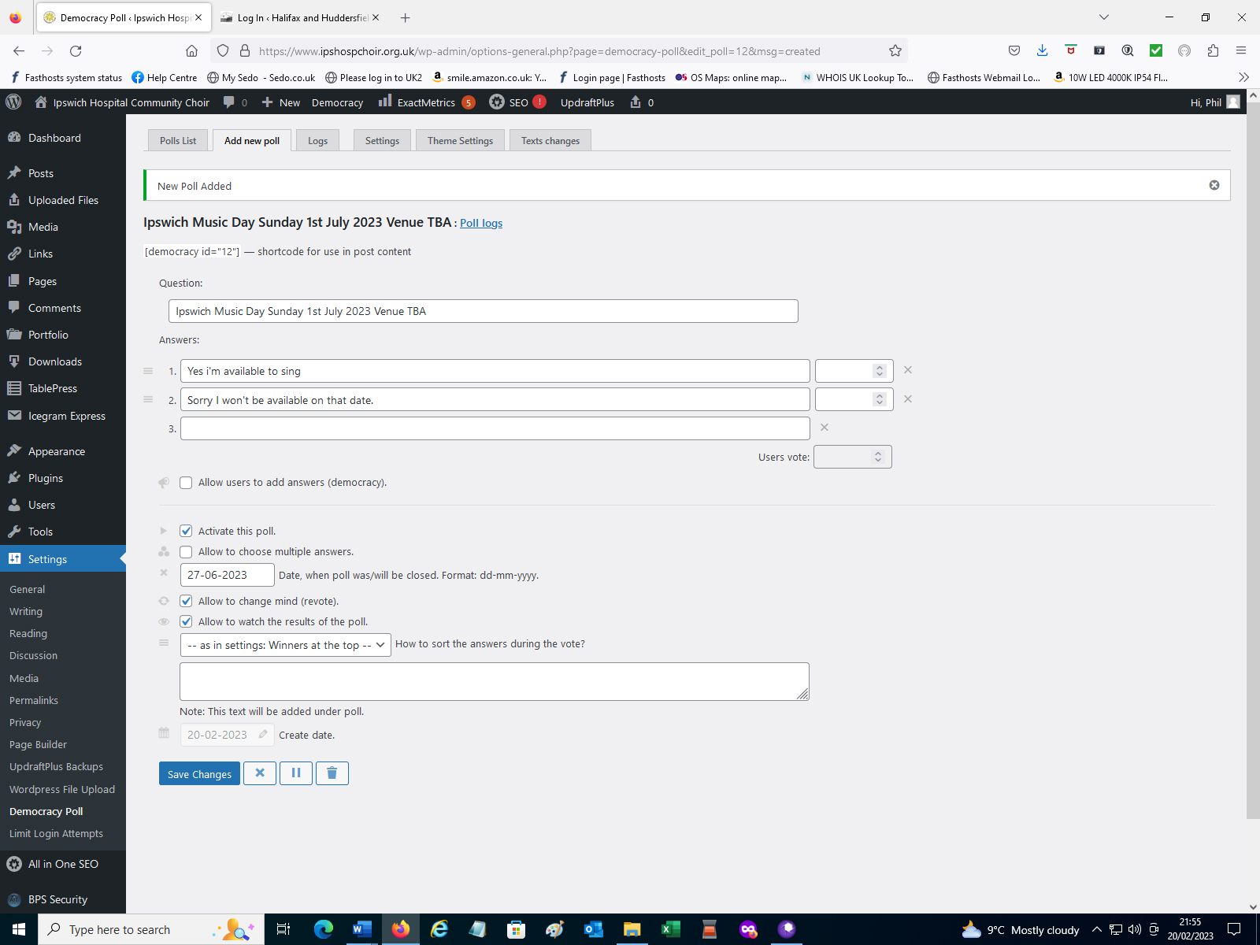
Go to the top of the page and under “Democracy” click on “Polls List”. You will two Polls listed “ID 12” which has just been created and “ID 6”which is an existing live Poll. Make a note of the ID numbers as in the next stage you will see how the Polls are ordered on the Polls Webpage.
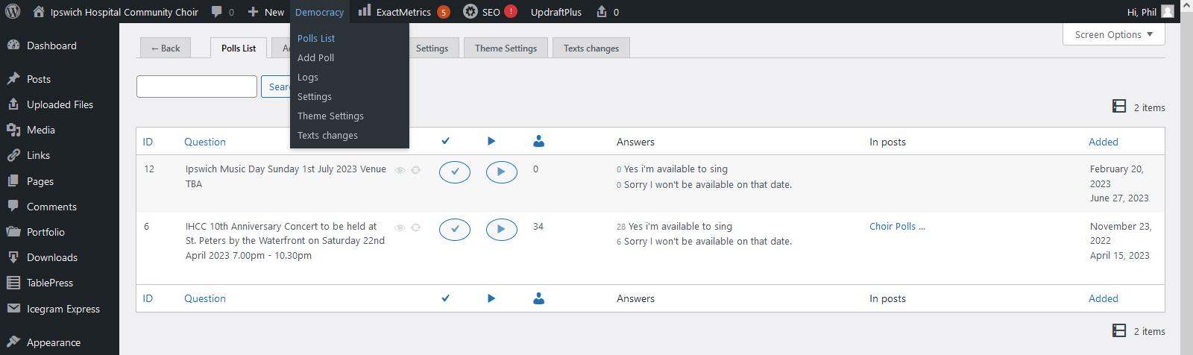

On the Dashboard side bar go to “Pages” and click on “All Pages”.
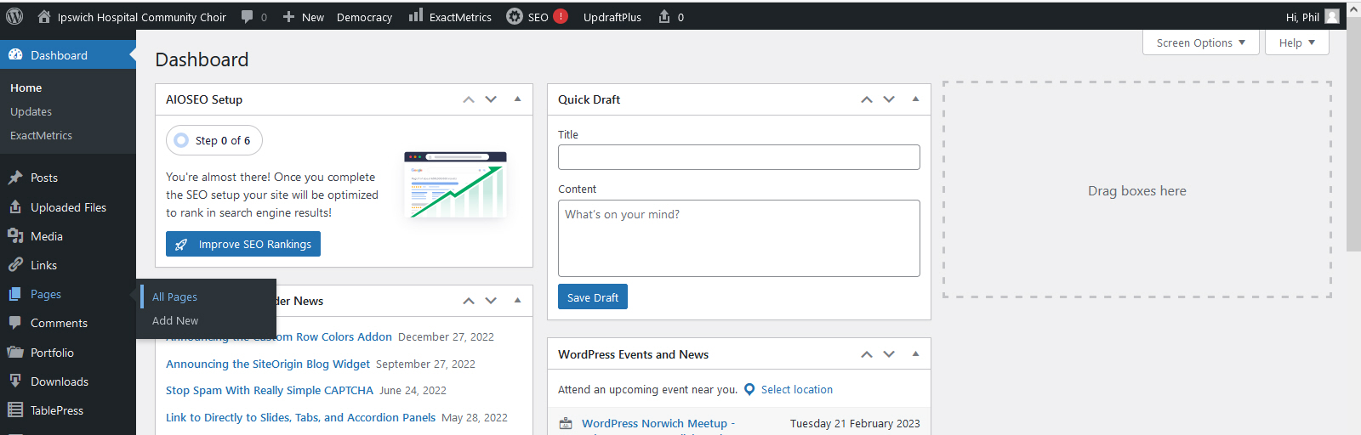
Look for the “Choir Polls” page in the list and click on “edit”.
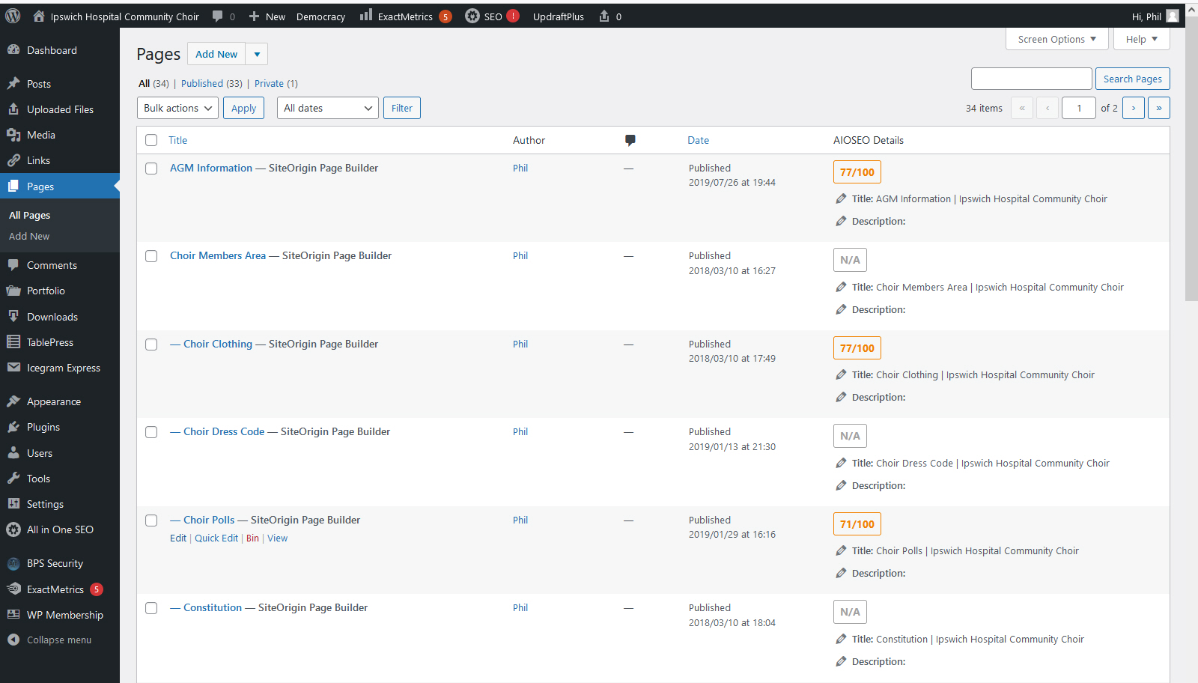
“ID 6” is already in use so in this example edit “ID=3” as this area on the Webpage will appear underneath the existing live Poll “ID=6”.
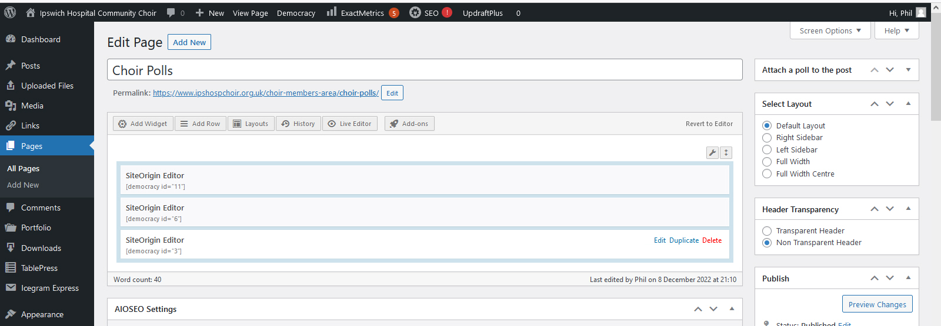
Edit the field displayed from a “3” to a “12” then click on “Done” in the bottom right-hand corner of the page.
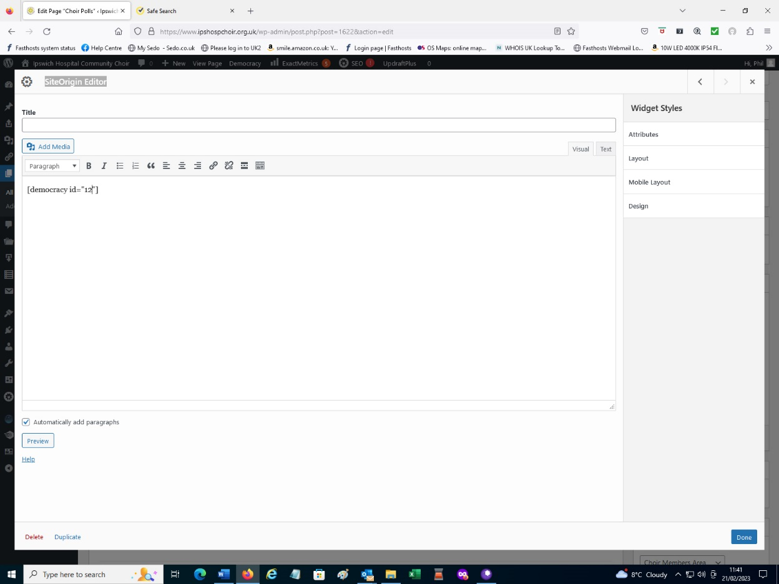
At the bottom right hand side of the page click “Update”. You now need to logout of admin and login as a choir member to check that your new Poll is being displayed.
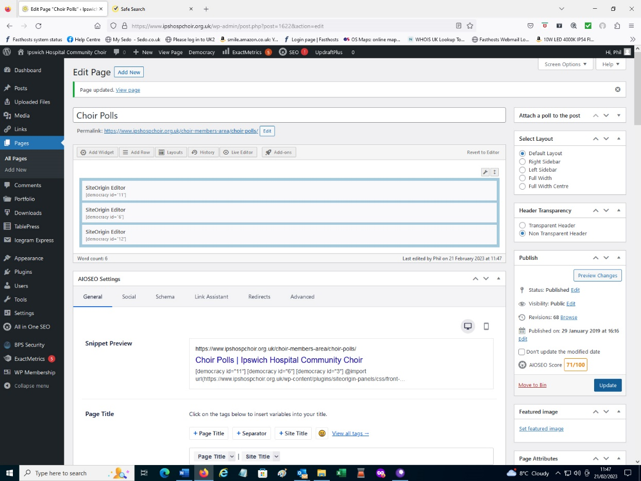

Once your vote has been cast the results will be displayed.
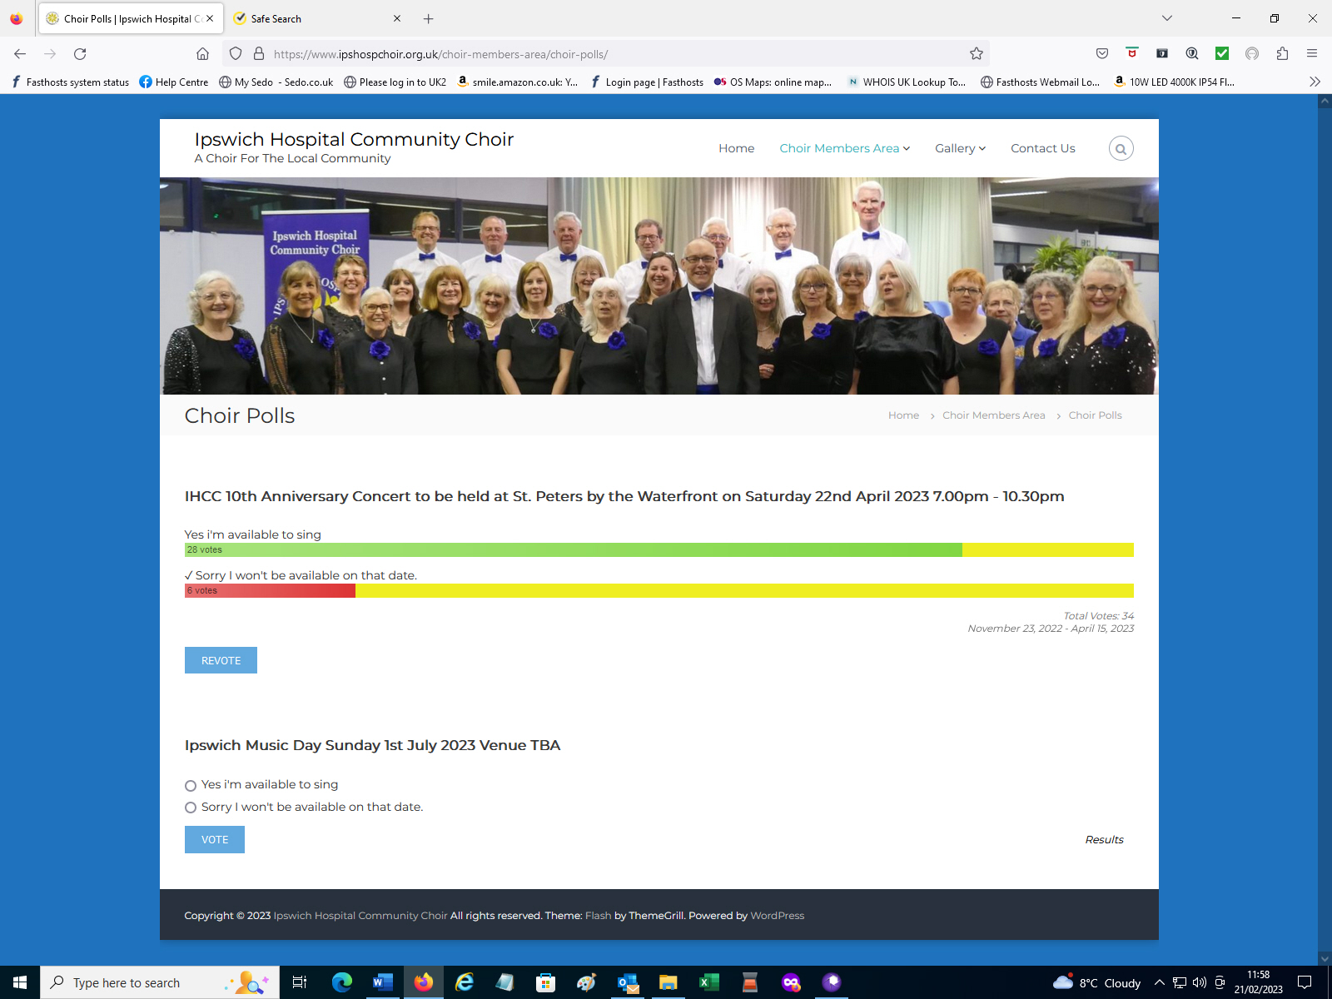

7. SIB Files Upload Procedure using FTP Client Software
Open FileZilla Client Click on “File” then “Site Manager”
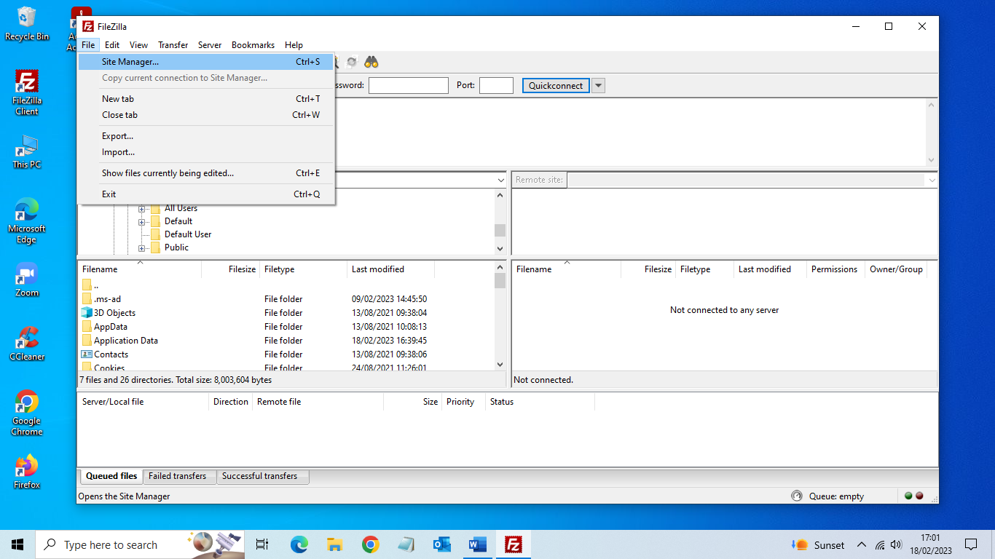

Enter under “My Sites” “IHCC” then under “General” settings enter the following: -
Host “ftp.ipshospchoir.org.uk”
User “ipshospchoir.org.uk”
Password “Afewscores4a$”
Then click on “Connect”

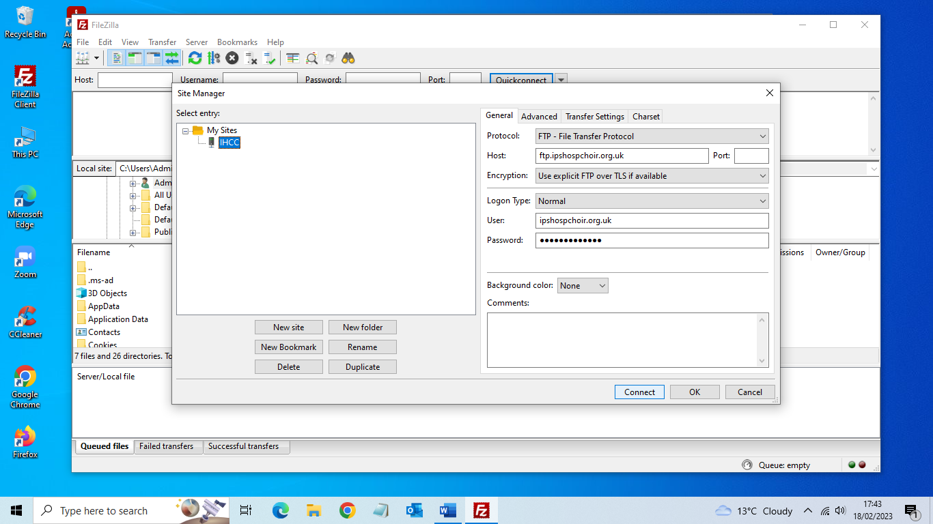

On the right hand side of the screen click on “wp-content”
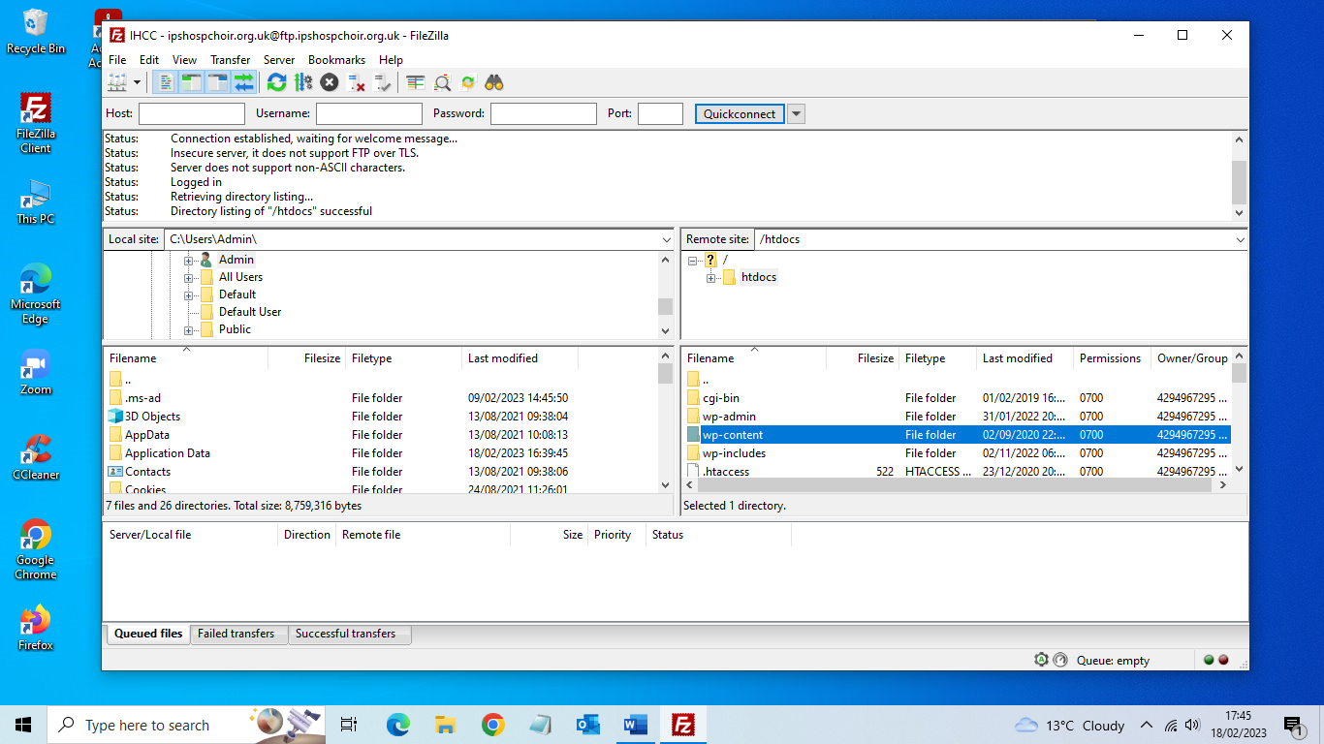

Then click on “uploads”

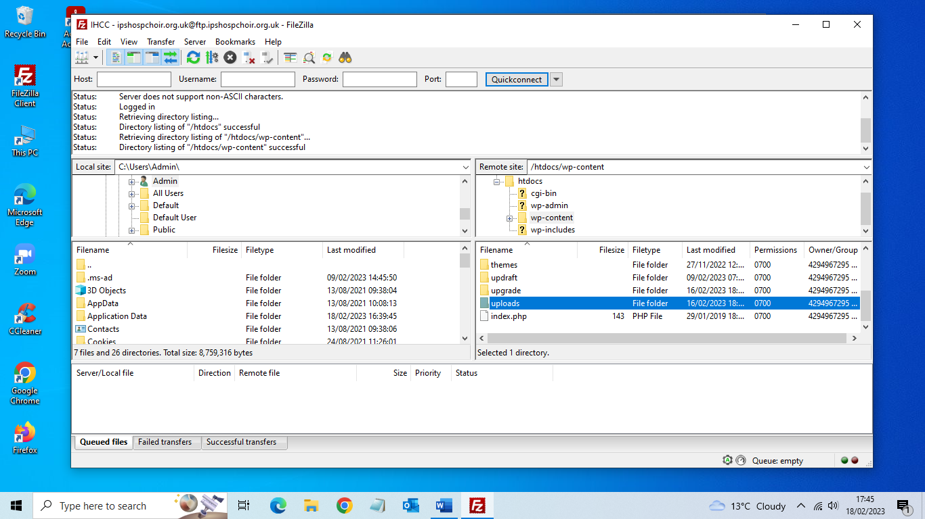

Click on the present year i.e “2023”
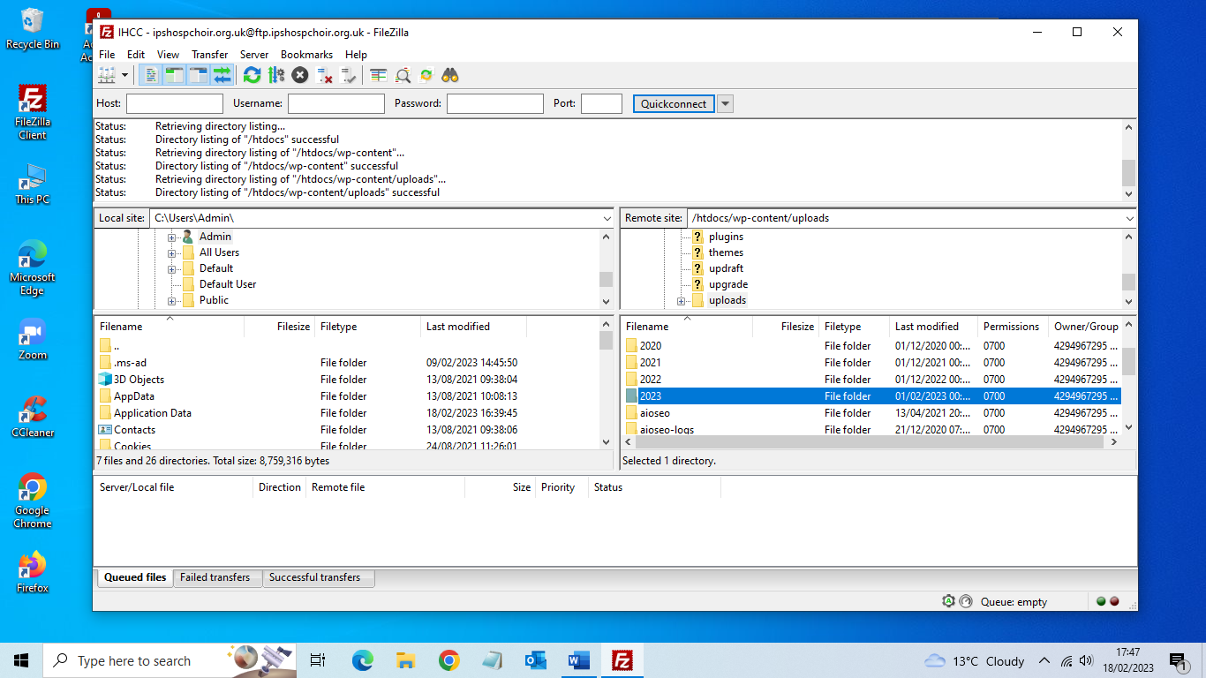

Then click on the latest month, in the example below “02” is selected i.e., February, as the year progresses a new folder will be created at the beginning of each month.

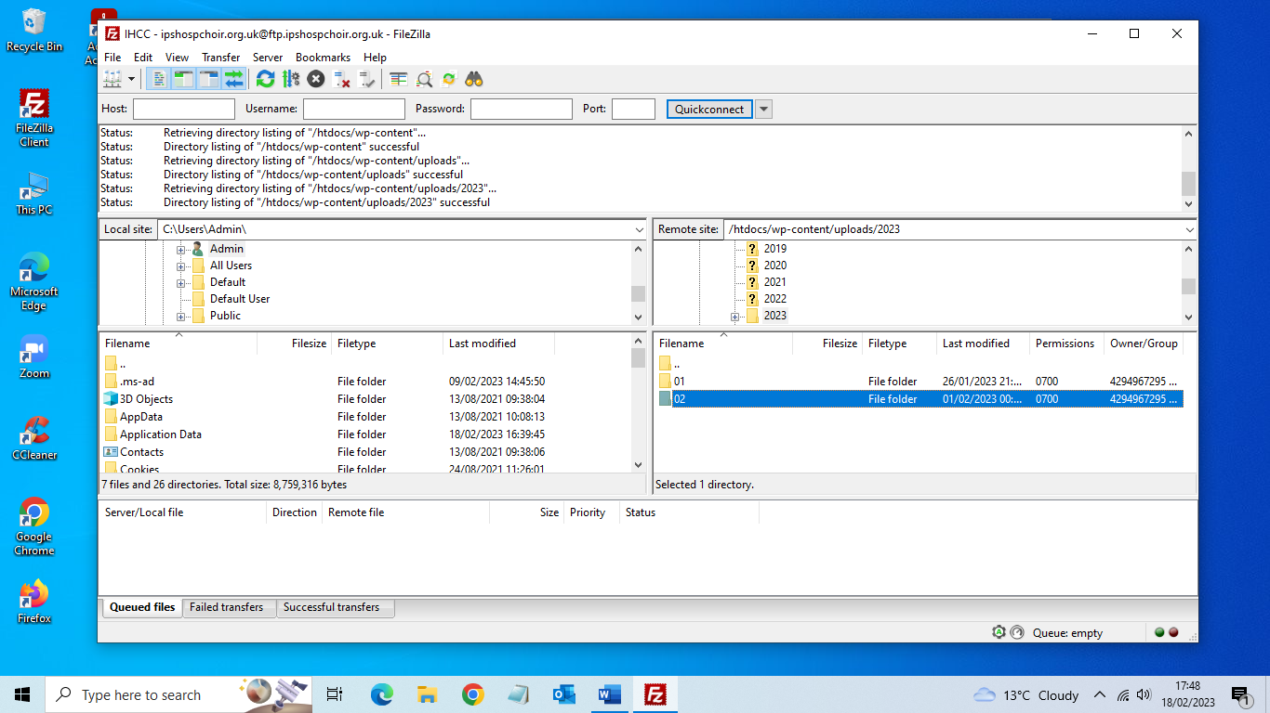

On the left hand side of the screen select the folder which contains the file to be uploade to the server.
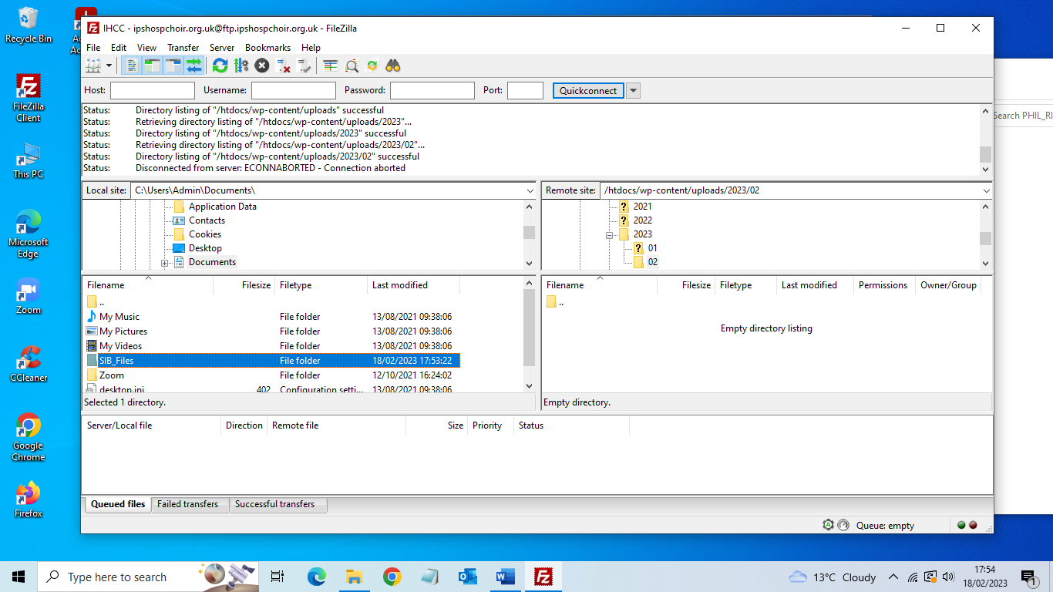

Select the file you wish to upload.

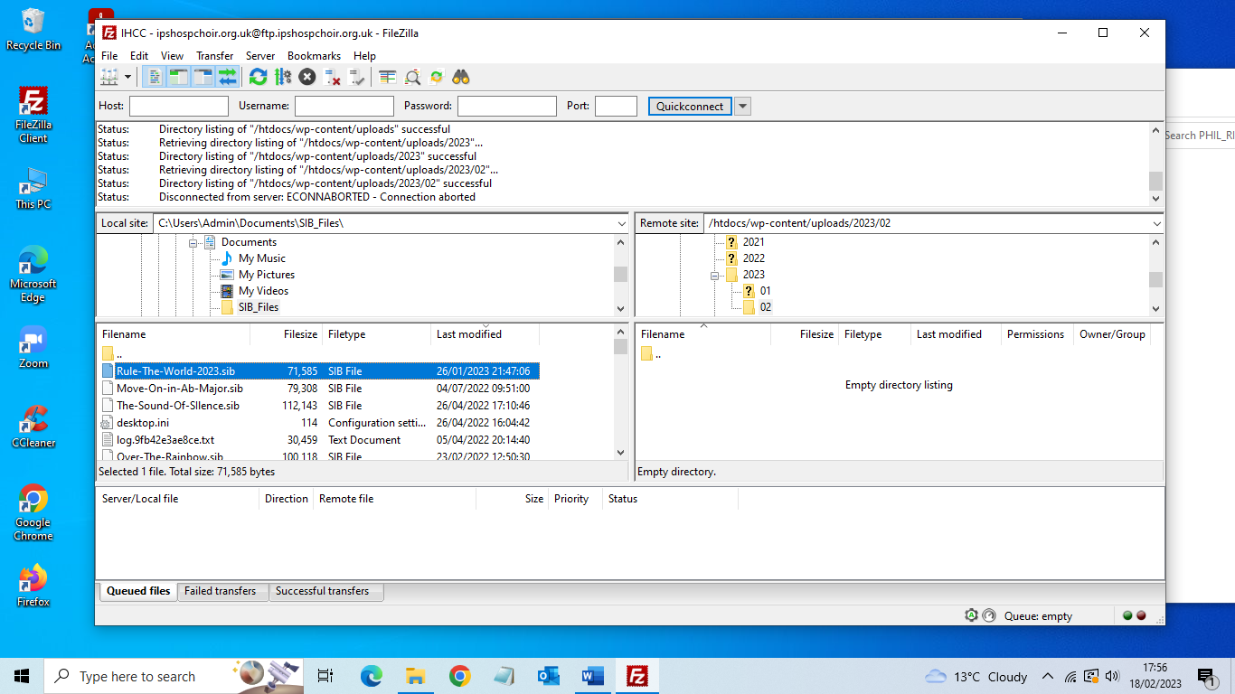

Drag the selected file to the right-hand side of the screen. Click on “Server” then “Disconnect”
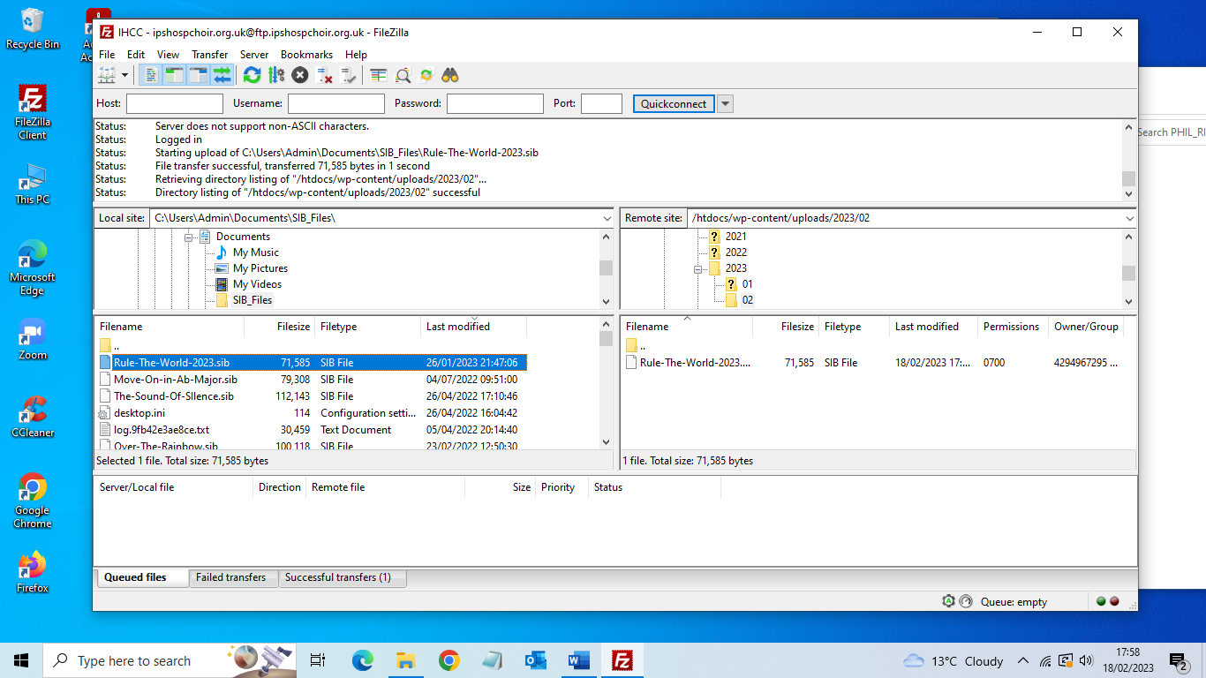

You can now exit the program. This concludes the FTP upload process.

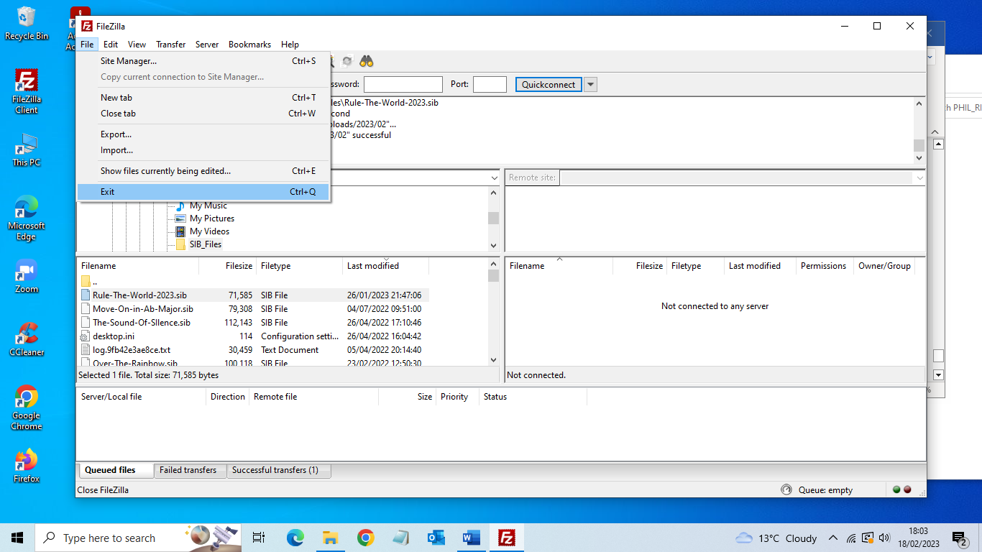

You now need to login to the website admin to generate the link to the file you have just uploaded.

https://Ipshospchoir.org.uk/admin

Under the Dashboard Menu select “Downloads” and “Add New”
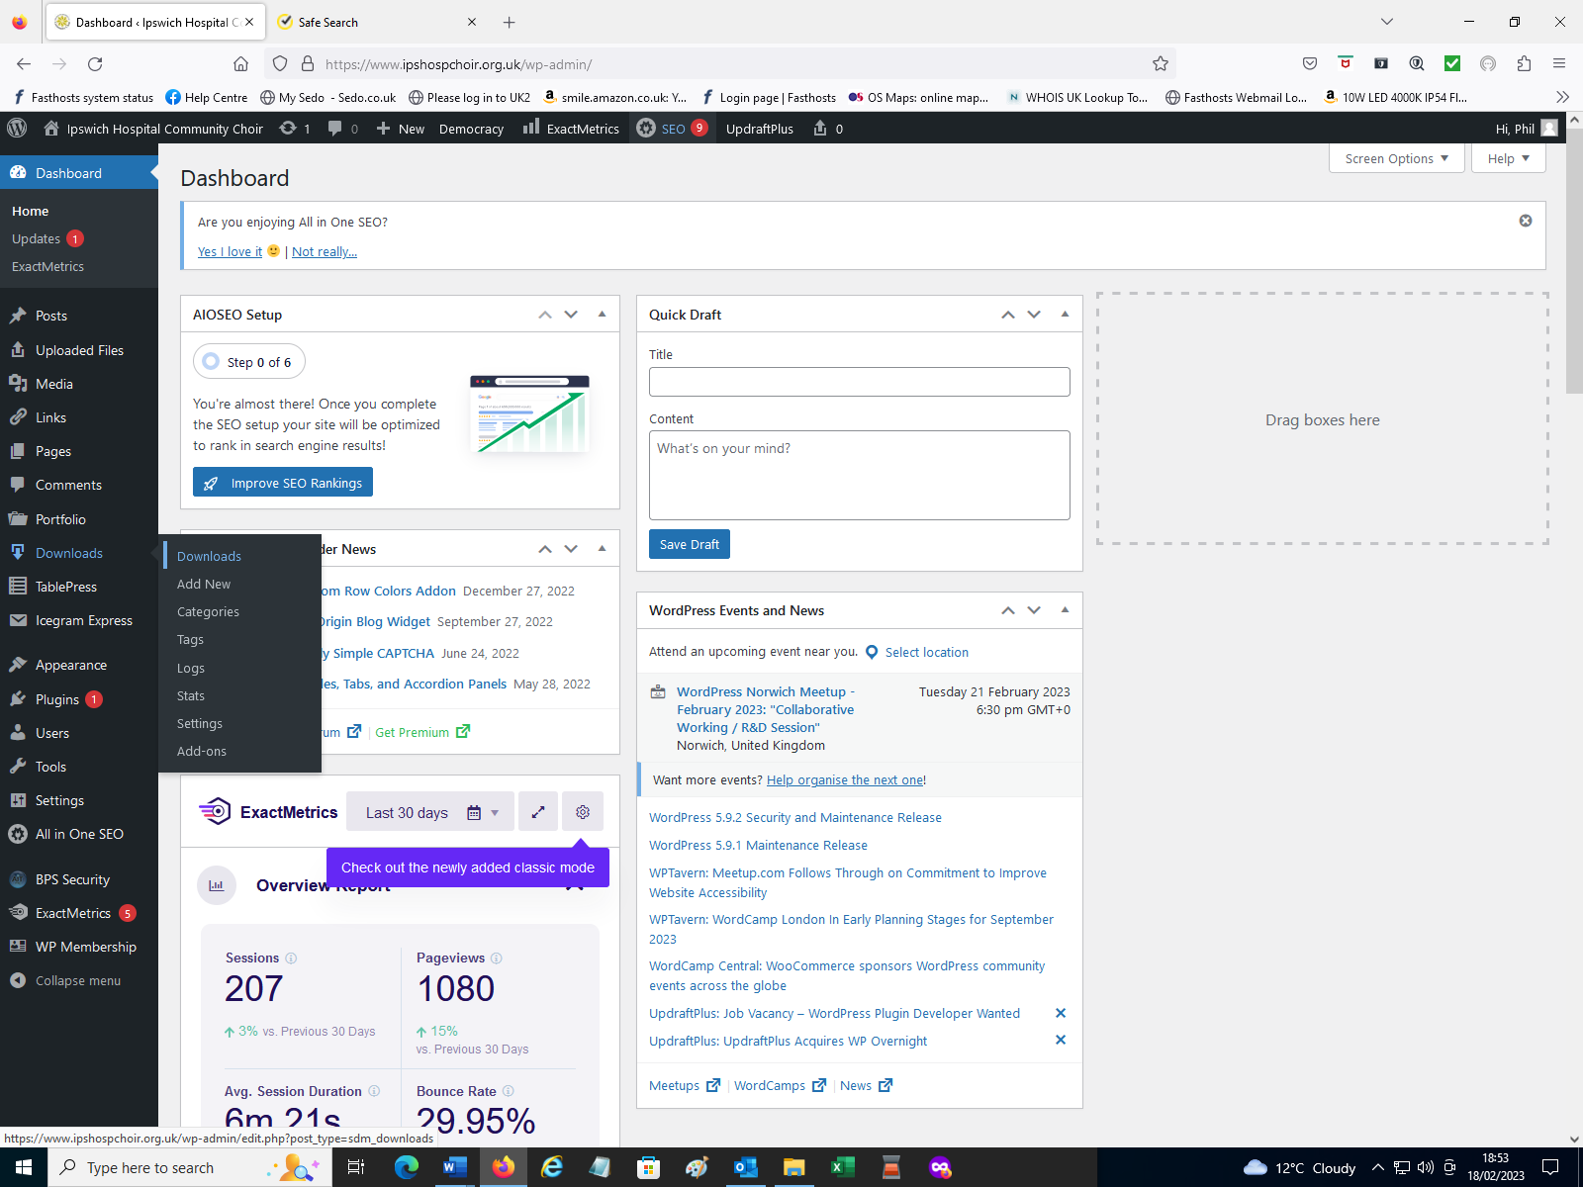
Add the title of the new SIB File and under “Download Categories” click on “Sib Files”
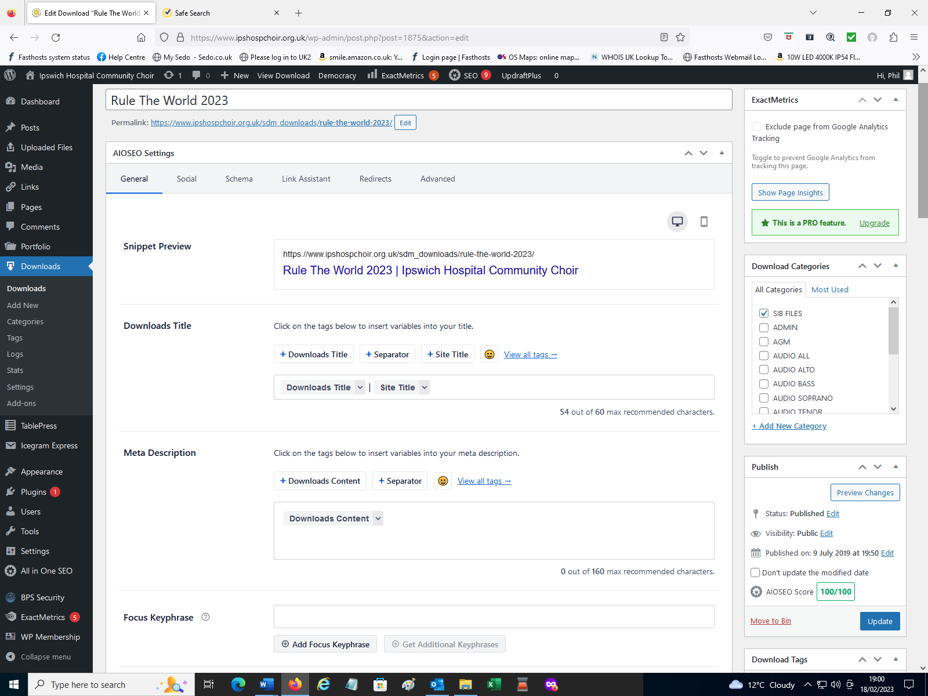

Under Downloadable File add the year\month\filename to: -
https://www.ipshospchoir.org.uk/wp-content/uploads/
i.e., https://www.ipshospchoir.org.uk/wp-content/uploads/2023/02/Rule-The-World-2023.sib
Tick the box under “PHP Dispatch or Redirect”
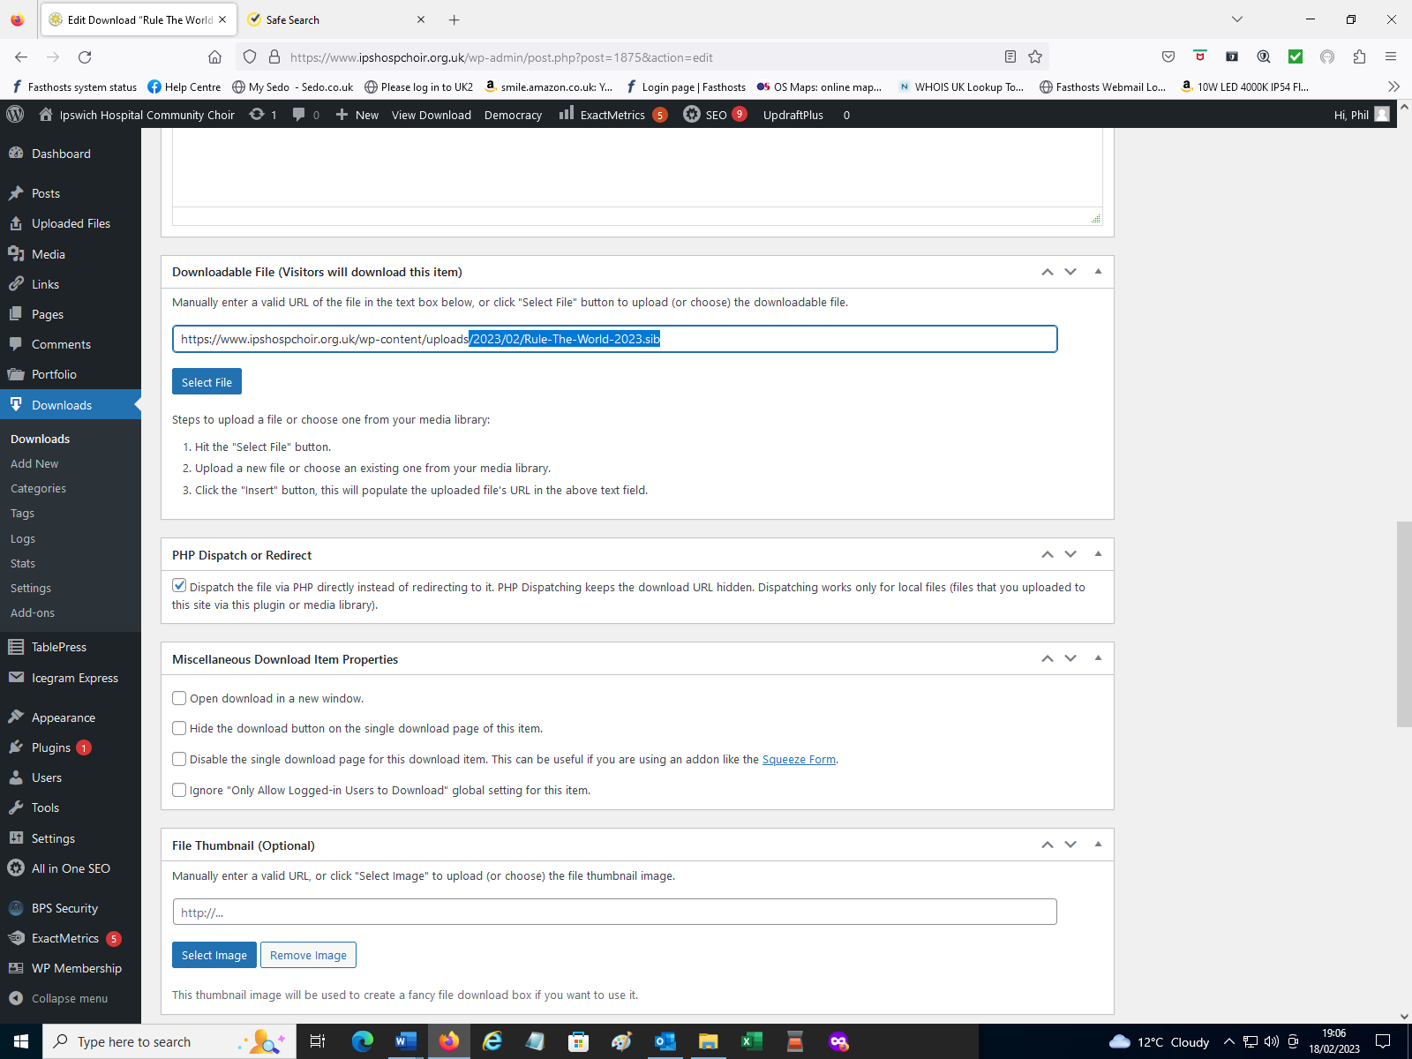
Don’t forget to tick the “Simple WP Membership Protection” You need to go back to the top of the page to “Publish” the new download. You can now logout of Admin and test your new download by logging into the Website as a choir member.
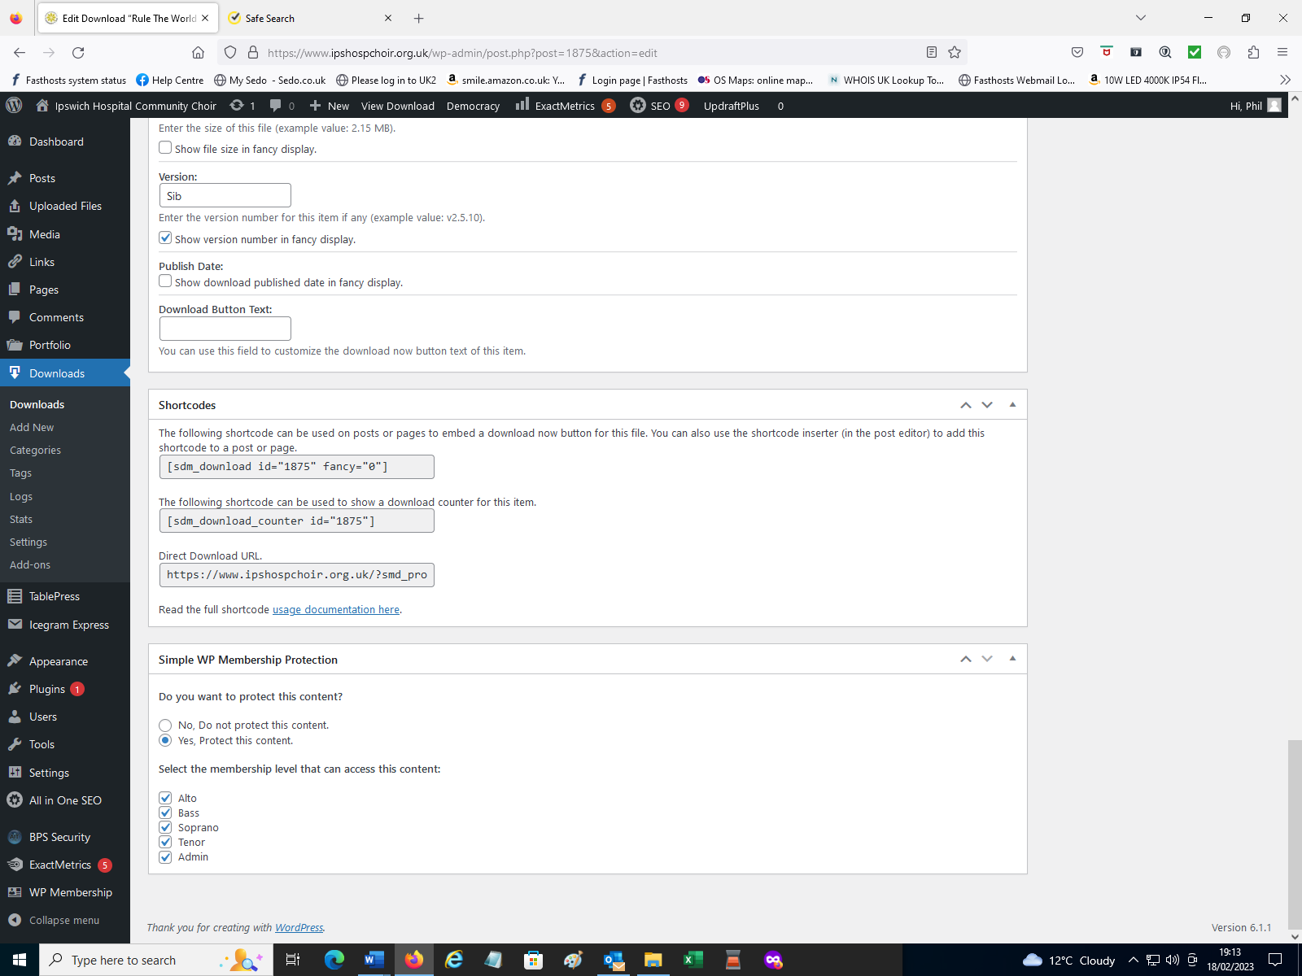

8. Trouble Shooting

8.1 Creating a Backup and down loading it.
IHCC Backup Procedure
Login as an Admin User and at the top of Dashboard screen select Updraftplus and then click on “Backup / Restore”.
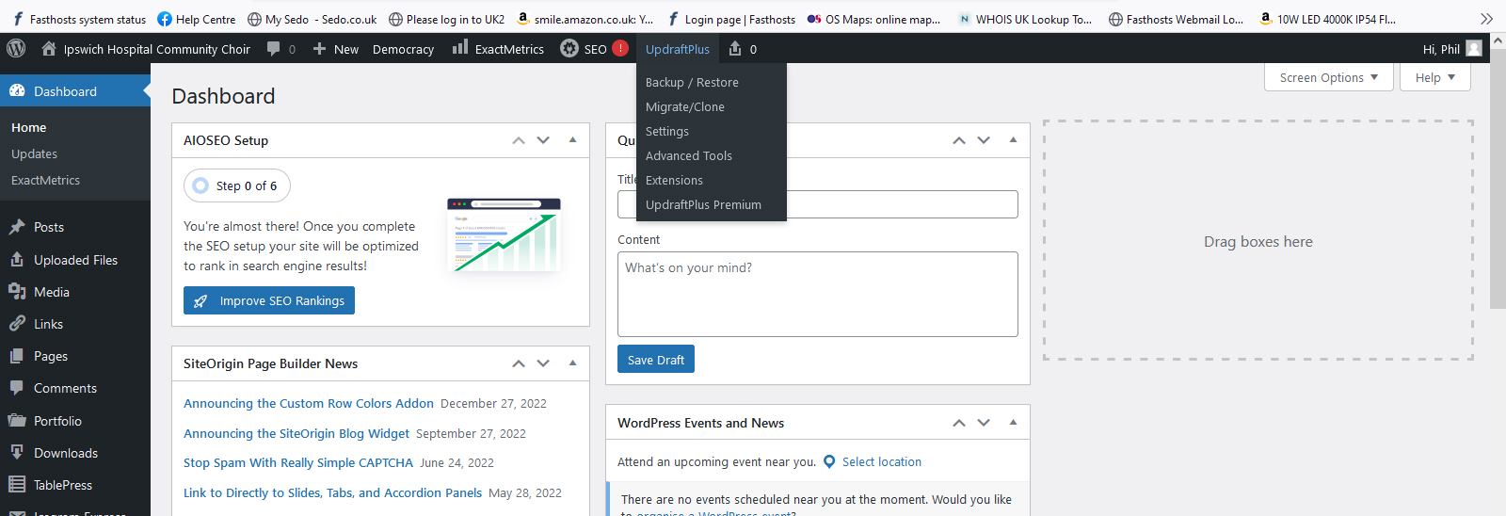
At the bottom of the page, you will see a section called “Existing backups”. You will see there are two listed. The application runs automatically every two weeks. Only two backups are kept, the oldest being deleted.
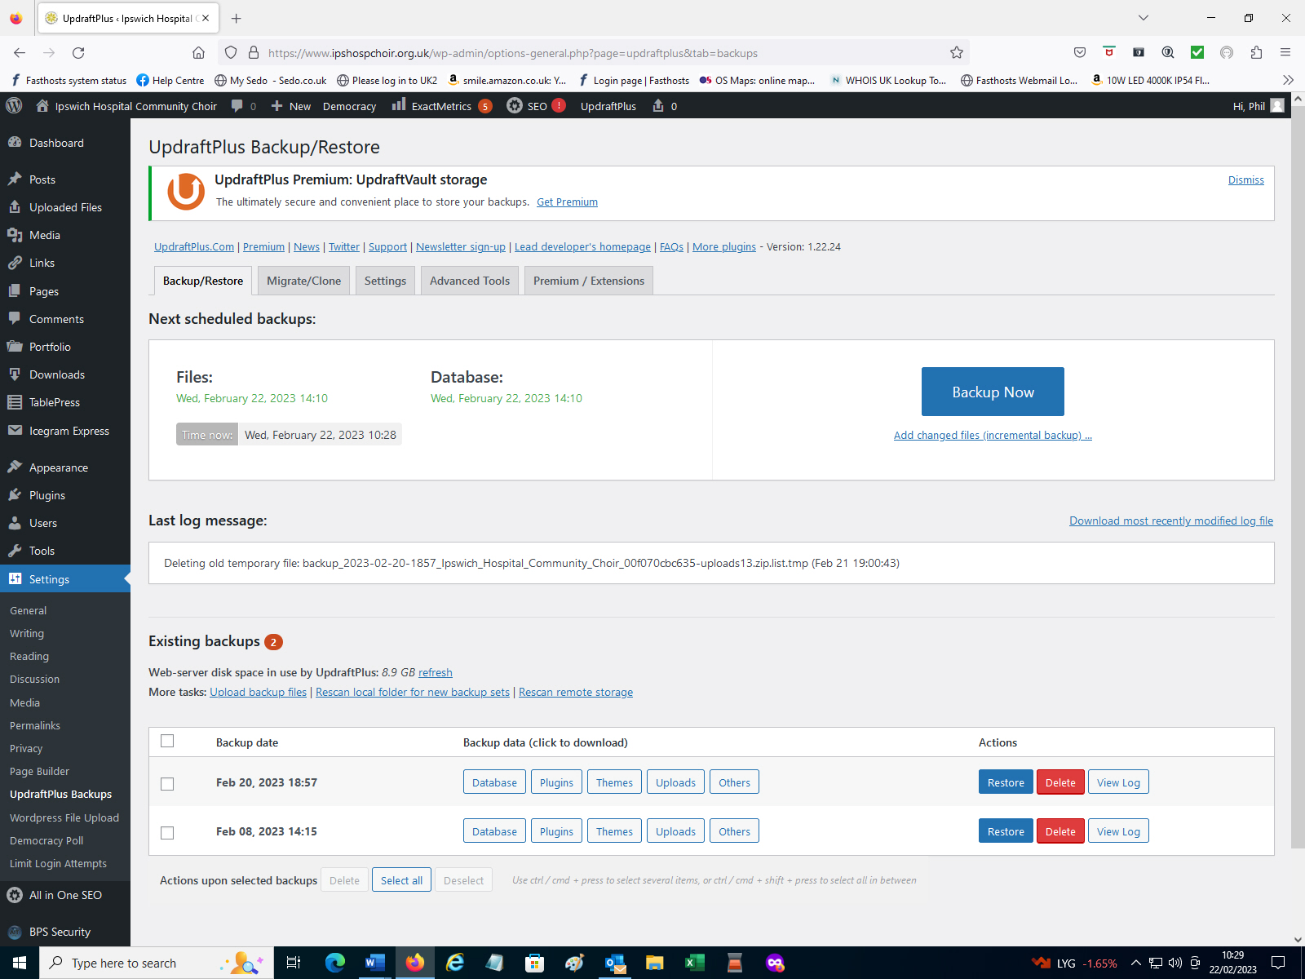

If a lot of updates have been carried out on the website it is good policy to run an ad-hoc one. Click on “Backup Now” to initiate. A popup screen will appear “Include your database in the backup” and “Include your files in the backup” they should both be already ticked. Click on “Backup Now”.
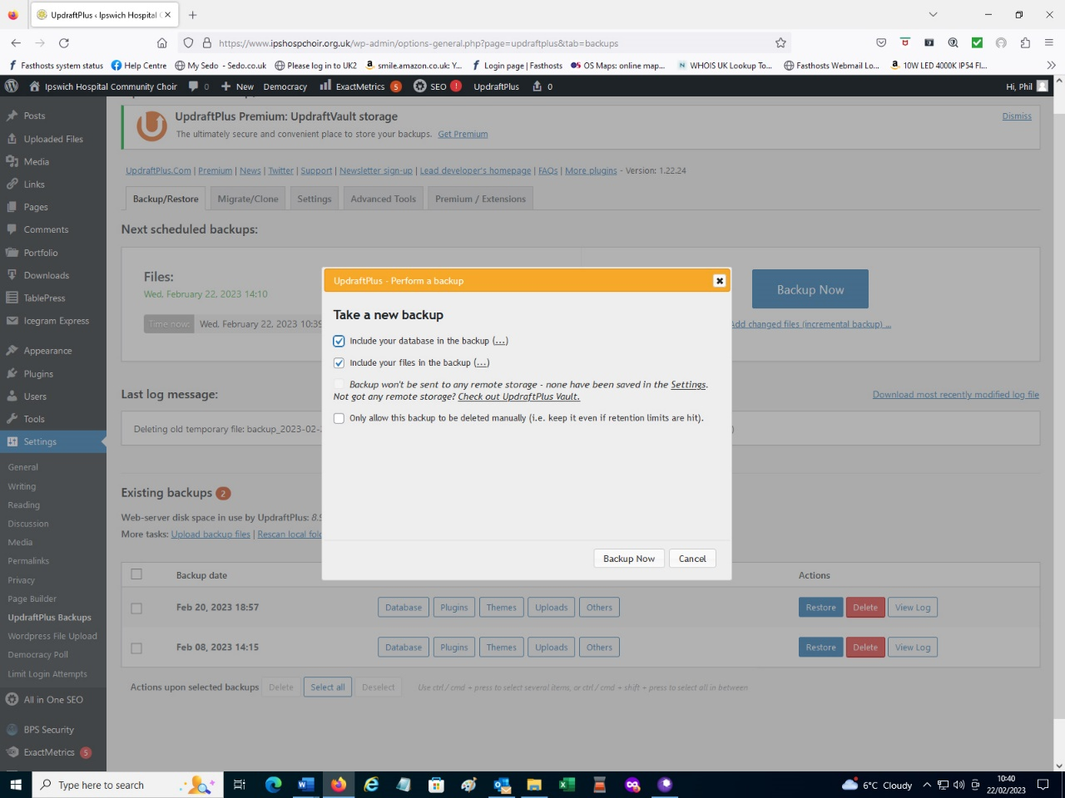
At the bottom of the page you will see that new backup is listed and the oldest backup has been deleted.
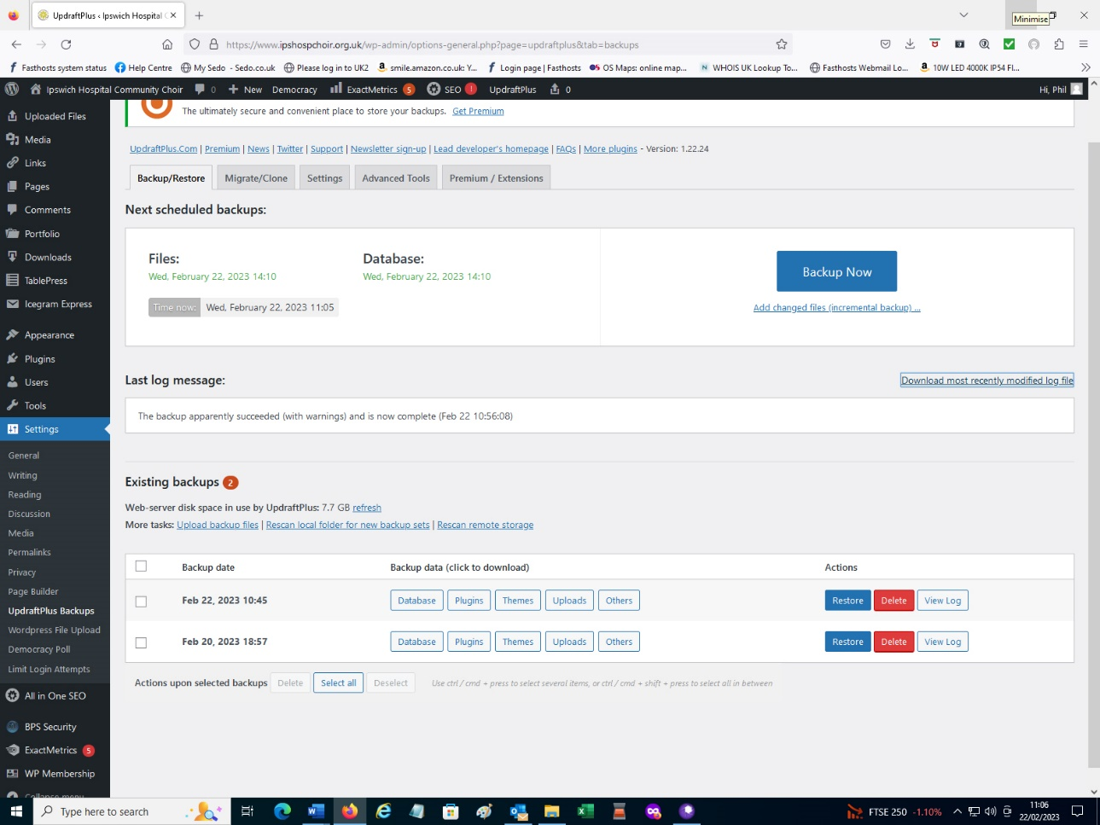

On the latest backup listed (Feb 22) click on “Database” a dialogue box will appear. Click on “Download to your computer”. Repeat this operation for “Plugins” ,“Themes”, “Uploads” , “Others”. There will lots of Upload Files downloaded all in zip format. These contain every file that has ever been uploaded to the website.
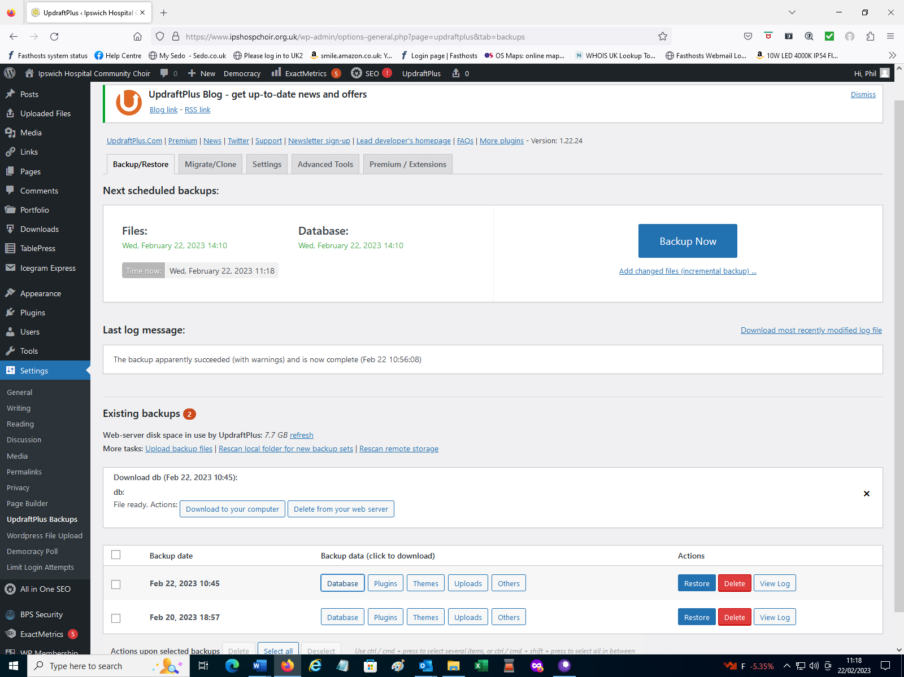

8.2 Checking Service Provider Status and Database status.
Control Panel

Log into www.controlpanel.co.uk
Username :- IHCC committee
Password :- IHCCemail4u
Login

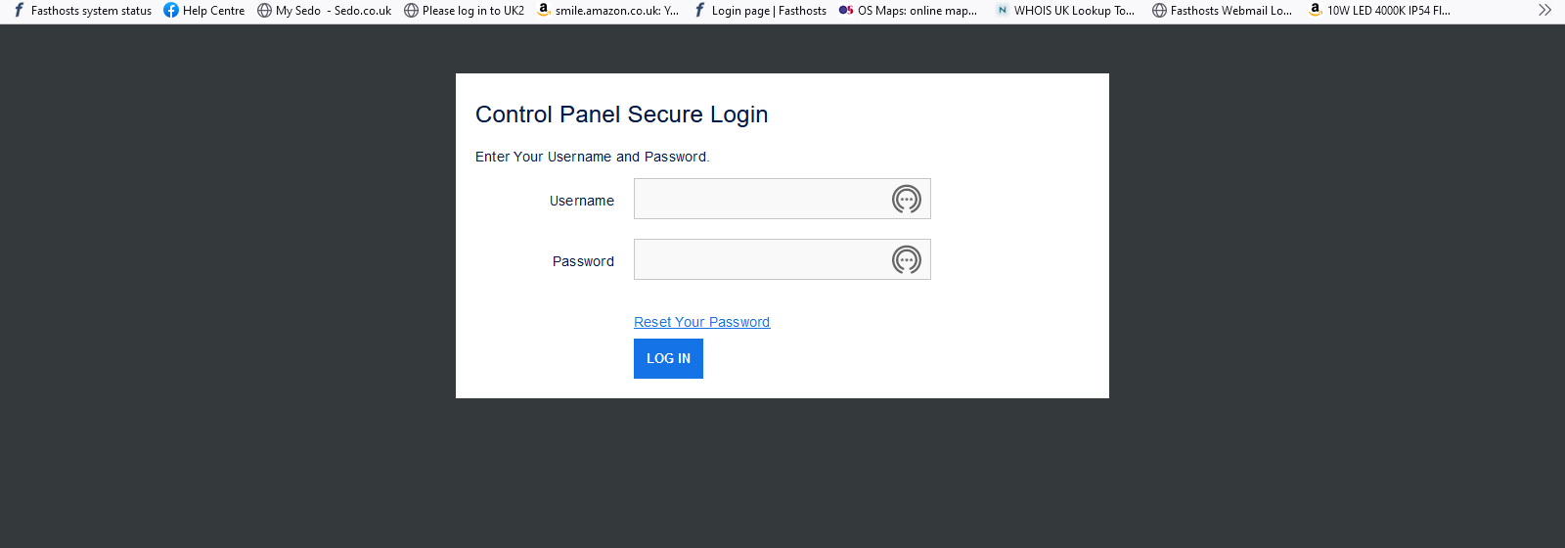

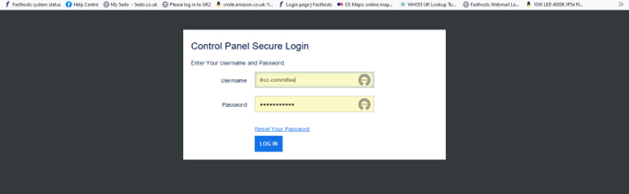
You will now presented this screen which gives you access to System status and Hosting and Email setup.
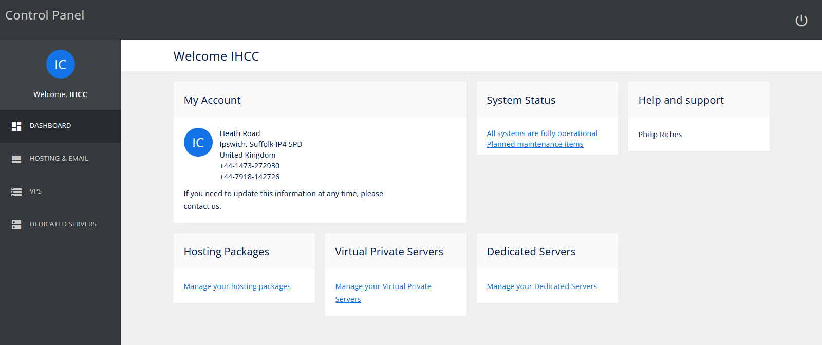
If there are access problems with the website click on Database “Configure”.
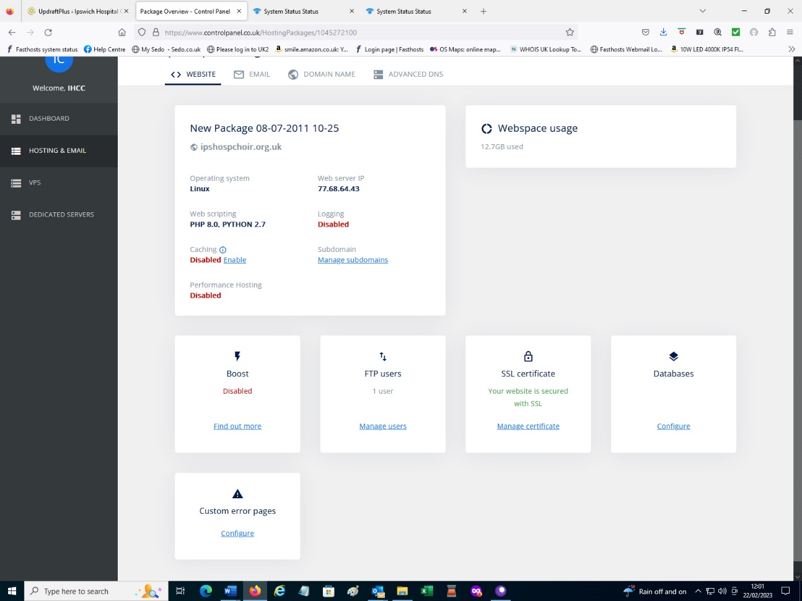

Click on”IHCC”
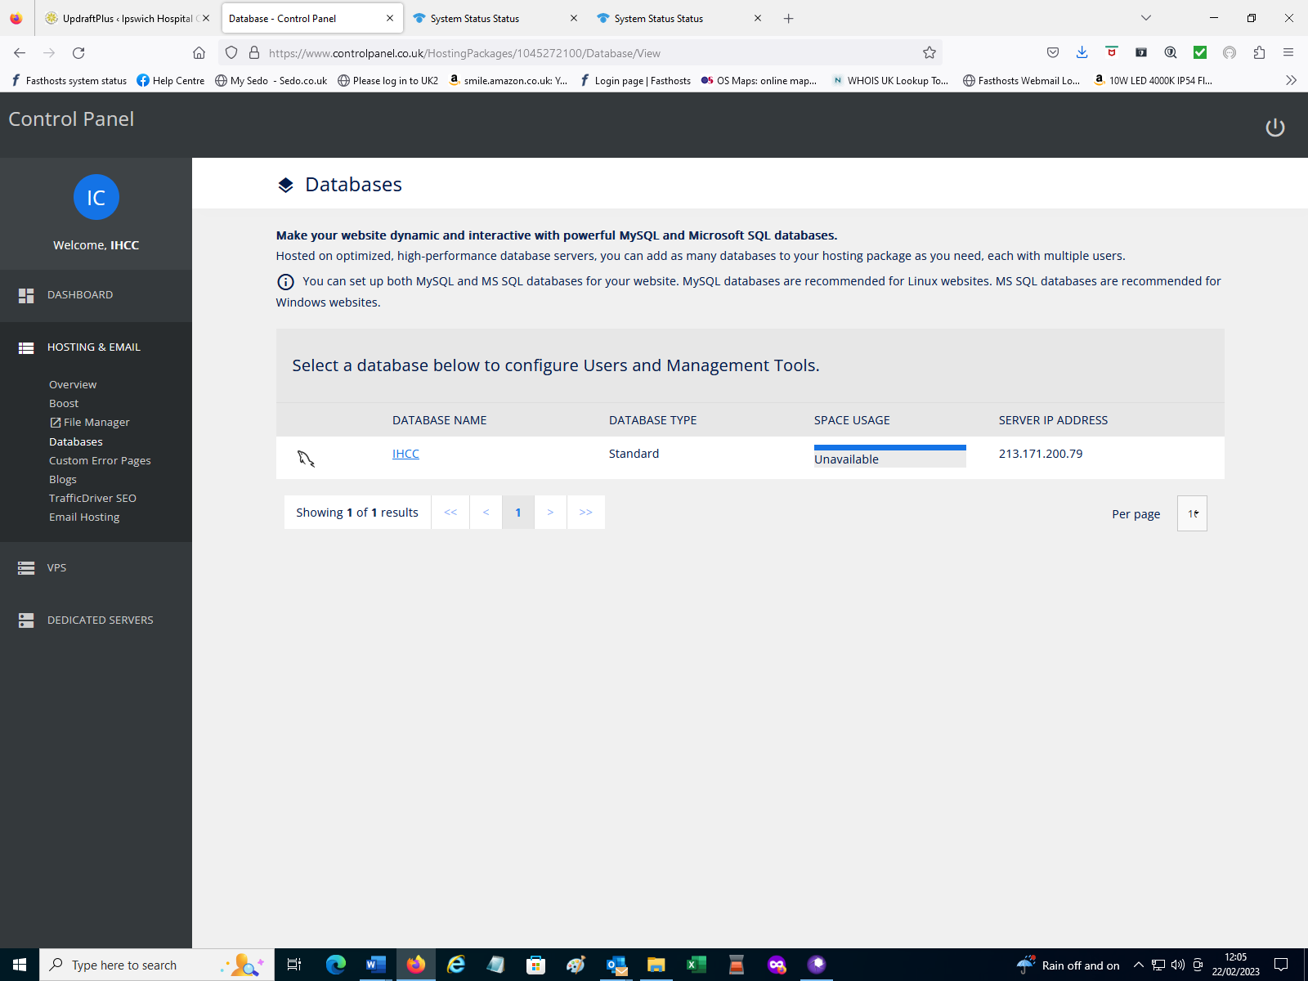

Click on “Check Status”
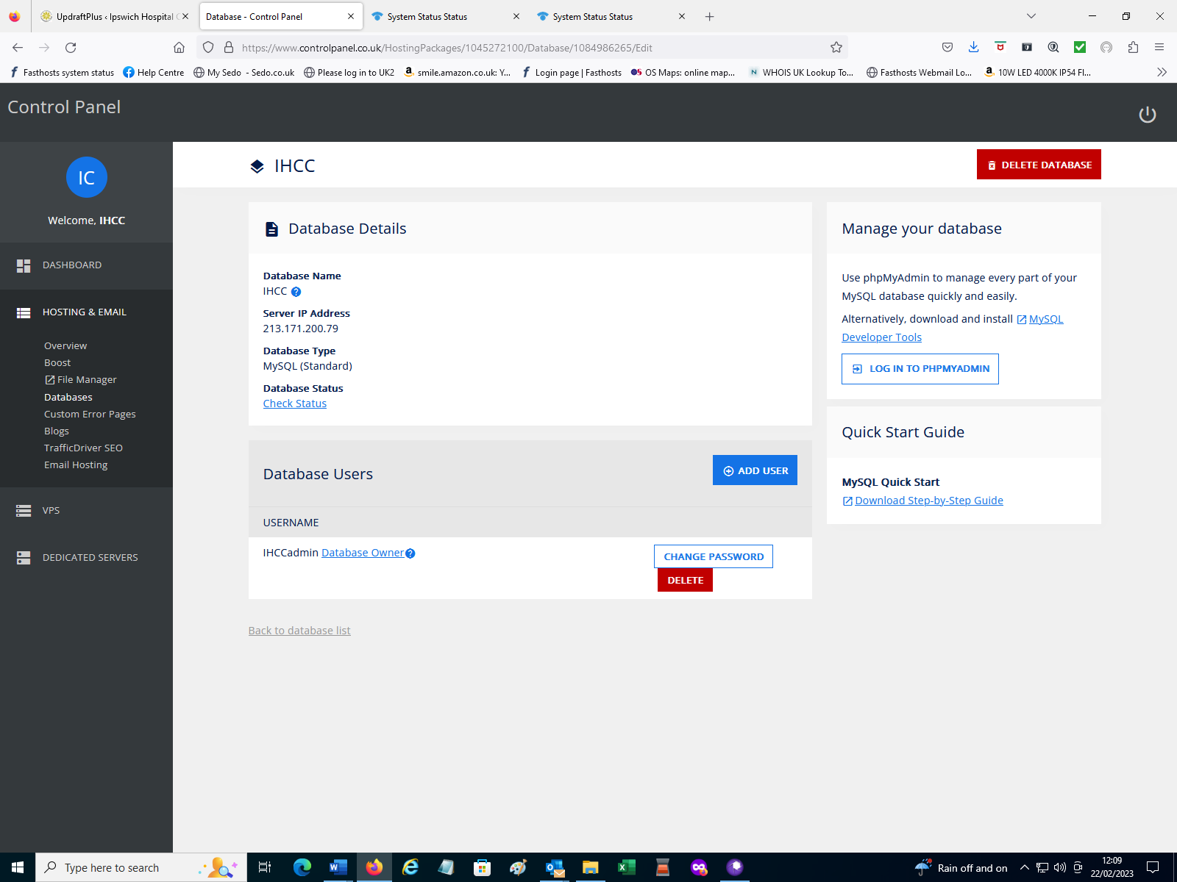

You should get a green banner “Your database IHCC does not currently have any known issues”.

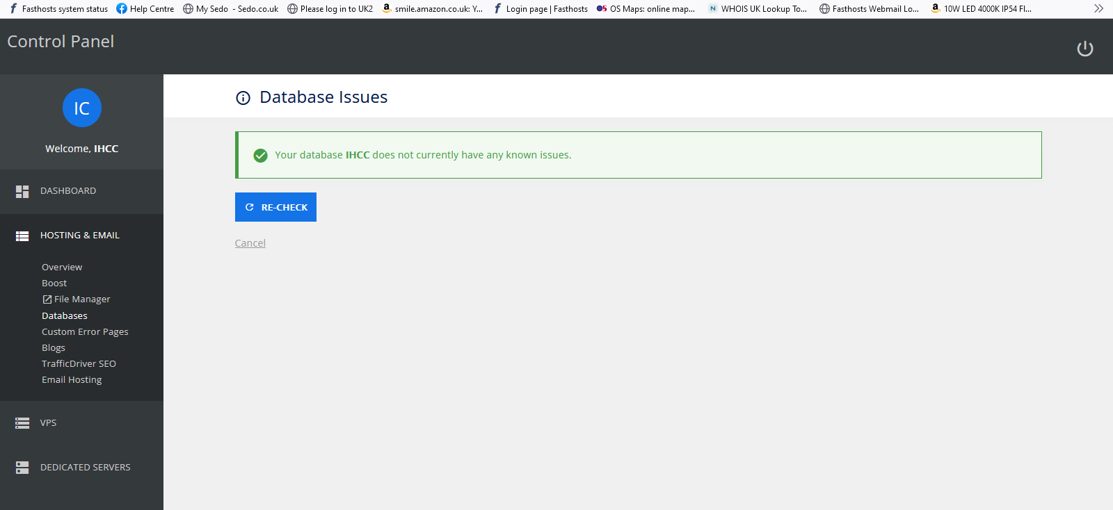

9. History
Issue | Date | Author | Comments
Draft A | 31/12/2022 | Phil Riches | Initial Draft.
Issue 1 | 22/02/2022 | Phil Riches | Issue 1

END OF DOCUMENT

